**BANGLADESH UNIVERSITY OF ENNGINEERING AND TECHNOLOGY**



**DEPARTMENT OF INDUSTRIAL AND PRODUCTION ENGINEERING**

Course: Data Science

Course Code: IPE 6107

**Submitted to:**

Assistant Professor Ridwan Al Aziz

**Submitted by:**

Ashiqur Rahman Khan - 0422082002

Zahidul Islam Sayeem - 0422082017

**A Machine Learning Approach for Predicting Malaria Based on Nigeria Malaria Indicator Survey (MIS) of** **Demographic and Health Surveys 2021**

**A Machine Learning Approach for Predicting Malaria Based on Nigeria Malaria Indicator Survey (MIS) of** **Demographic and Health Surveys 2021**

**Abstract**

Malaria is a deadly disease if it is not treated with immediate approach. Nigeria is the hotspot of Malaria in Africa with 31.3% of the total malaria death population. Detection of malaria is another tough task. Demographic and Health Surveys 2021 of Malaria report shows that *the Rapid Malaria test* may miss the chance to give accurate result. It also shows that a *Final result of malaria from blood smear test* gave malaria positive result but the *Result of malaria rapid test* gave negative result. In this case, it becomes hard to give proper treatment to the patient as enough time is lost due to *Final result of malaria from blood smear test* which consumes so much time for giving results. To overcome these limitations predictive analysis like Machine Learning (ML) algorithms can be implemented. In this study, ML algorithms Logistic Regression (LR), Decision Tree (DT) and H2O Automated Machine Learning (AutoML) framework are implemented on Demographic and Health Surveys 2021 of Malaria of Nigeria dataset. Generalized Linear Model (GLM) and Stacked Ensemble algorithms of H2O AutoML showed better result over LR and DT on original dataset and random oversampled dataset respectively. GLM and Stacked Ensemble showed 99.87910% and 99.9267% accuracy respectively. GLM also identified top four important features Presence of species: falciparum (Pf), Presence of species: malariae (Pm), Mother's highest educational level and Presence of species: ovale (Po) which plays a vital role in predicting malaria.

**1. Introduction**

**1.1 Background**

Malaria is a disease caused by Plasmodium parasites. Generally, it spreads to people by the bites of infected female Anopheles mosquitoes. Beside mosquito there are other 5 parasites that also cause malaria. P. falciparum and P. vivax are responsible for the greatest threat. On African continent the deadliest malaria parasite is P. falciparum and outside of the sun-Saharan Africa P. vivax is the dominant malaria parasite. The initial symptoms of malaria are fever, headache and chills. The symptoms appear after 10 to 15 days of infection by the bite of mosquito. It becomes very difficult to recognize the disease as malaria and sometimes left untreated. When left untreated and if the malaria is caused by P. falciparum, then within 24 hours patient progress to severe illness to death. Half of the population was at risk in 2021 due to malaria. Infants, children under age of 5, pregnant women and patients with HIV/AIDS are considerably at high risk. People with low immunity moving to intense malaria transmission area also at high risk. According to the World malaria report there were 247 million cases in 2021 compared to 245 million cases in 2020 and the estimated death due to malaria 619000 in 2021 and 625000 in 2020. In 2021 the African region was the home of malaria with 95% of all malaria and 96% of death of all malaria cases and death population. Nigeria is leading the percentage of deaths due to malaria with 31.3% of the total malaria death population [1].

**1.2 Motivation**

Though the test result of having malaria is provided within 2 to 15 minutes, but is the result is negative and still having symptoms of malaria then it needs to provide blood smears every 12 to 24 hours over a period of two to three days [2][3]. We also know that it’s very hard to identify, the patient is affected with malaria or not. And if left untreated then the patient may lead to death within 24 hours [1]. The dataset used in this study also shows that in a “Result of malaria rapid test” about 267 tests shows negative result but later on it was found that all those results became positive in a “Final result of malaria from blood smear test” [4]. So, if the test fails to identify, then the patient is at high risk to death. The medical test may fail to identify in initial stage, and may take enough time to figure out the actual result, what if the patient leads to no return stage within that time.

There are millions of cases of malaria and are being recorded every year in a structed way. By analyzing those data predictive models as Machine Learning (ML), Deep Learning (DL), etc. models can be used to predict the probability of a patients having malaria without medical test and preliminary treatments can be started based on the result of those predictive models. Medical tests will have to be done parallelly as predictive models are only for initial stage only.

**1.3 Summary: Expected results and insights**

Machine Learning, Deep Learning and Artificial Intelligence etc. are the leading technology in this era. There are many well-known efficient algorithms exists nowadays for predicting with high accuracy and precision.

For predicting malaria (positive or negative) based on household data can be a new approach beside biological parameters. Models like Logistic Regression (LR), Decision Tree (DT), Automated Machine Learning (AutoML) framework H2O can be implemented for predicting the outcome of having malaria. Best model can be identified by comparing the performance measures of those models.

AutoML H2O may perform better than other models. Performance of Traditional ML models depends on the expertise of the users. But AutoML is an off-the-shelf ML method [5] it is a self-learning method which can provide best performing model after having trial of as many models as user wants.

**2. Literature Review**

**2.1 Current Knowledge**

Decision making technologies like Machine Learning, Artificial Intelligence, Deep learning etc. have opened a new era for health care sector. Nowadays health care experts may use these types of decision-making technologies for analyzing the patient’s history with random multiple parameters. This may lead the experts to give decisions within a short time and in health care sector fraction of second is very vital for patients. These technologies in health care will reduce the human error and increase the efficiency to predict the disease. In the case of malaria, it is hard to predict the disease until it shows the symptoms. Even though sometimes it is hard to get the correct result by rapid test. Researchers tried to predict malaria positive or negative from various types of factors like clinical factors, RNA sequencing, image processing from blood sample, biological factors etc. Some recent researches on malaria using predictive models are going to be mentioned in Section 2.2 literature review table.

**2.2 Literature Review Table**

Table.1: Literature Review Table

|  |  |  |  |  |  |  |  |  |
| --- | --- | --- | --- | --- | --- | --- | --- | --- |
| **SL No.** | **Title** | **Author** | | **Method** | **Predictors** | **Outcome** | | **Data**  **Source** |
| 01 | Predicting malarial outbreak using Machine Learning and Deep Learning approach: A review and analysis [6] | Godson Kalipe et al  Year: 2018 | | 1. K Nearest Neighbors (KNN)  2. Random Forest (RF)  3. Support Vector Machine (SVM)  4. Extreme Gradient Boosting (XGBoost)  5. Logistic Regression (LR)  6. Artificial Neural Network (ANN)  7. Naïve Bayes (NB)  9. Accuracy  10. Precision  11. Recall  12. Error Rate  13. Matthews Correlation Coefficient (MCC)  14. Specificity  15. False Positive Rate (FPR) | 1. Minimum temperature  2. Maximum temperature  3. Humidity level  4. Ratio of the number of malaria cases by the population | Outbreak  (Predict malaria) | | 1. National Vector Borne Disease Control Program  2. Indian meteorological Centre and Cyclone Warning Center |
| 02 | Machine learning model for predicting malaria using clinical information [7] | You Won Lee et al.  Year: 2020 | | 1. Synthetic Minority Oversampling Technique (SMOTE)  2. SVM  3. RF  4. Multilayered Perceptron (MLP) 5. AdaBoost (Ada)  6. Gradient boosting (GB)  7. CatBoost (CB)  8. Accuracy  9. F1-Score  10. Precision  11. Recall  12. Cross-validation (CV)  13. Feature Importance by RF  14. Area under curve (AUC) | 1. Gender  2. Age  3. Nationality  4. Symptomic body region  5. Symptom | Predict malaria | | 1.Center for Disease Control and Prevention (CDC)  2. PubMed |
| 03 | Prediction of malaria incidence using climate variability and machine learning [8] | Odu Nkiruka  et al.  Year: 2021 | | 1. K-means clustering  2. XGBoost  3. SVM  4. NB  5. LR  6. Accuracy  7. AUC  8. CV  9. Variance Inflation factor (VIF)  10. Receiver Operating Characteristic Curve (ROC) | 1. Precipitation  2. Surface Radiation,  3. Temperature  4. Atmospheric pressure  5. Relative Humidity | Case of Malaria  Increase or decrease | | 1. WHO data repository  2. National Centre for Atmospheric Research (NCAR) |
| 04 | Machine Learning based Malaria Prediction using Clinical Findings [9] | Samir S. Yadav  et al.  Year: 2021 | | 1. NB  2. LR  3. Decision Tree (DT)  4. RF  5. SVM (kernel=gaussian)  6. SVM (kernel=polynom)  7. ANN(MLP)  8. Accuracy  9. Precision  10. Recall  11. F1-Score  12. AUC  13. ROC | 1. Address  2. Days  3. Sex  4. Death  5. Diagnostic  6. Hospitalization  7. Month  8. Number of patients  9. Number of visit days  10. Observation  11. Rapid Diagnosis Test  12. Reverence  13. Signs – symptoms  14. Treatment  15. Weeks  16. Years | Malaria or Not Malaria | | 1. Distinct Places in Senegal, collected in 2016 during the “Grand Magal of Touba”  2. Medical records of the districts Diourbel, Thies and Fatick |
| 05 | ICA Learning Approach for Predicting of RNA-Seq Malaria Vector Data Classification Using SVM Kernel Algorithms [10] | Micheal  Olaolu Arowolo  Year: 2022 | | 1. Independent component analysis (ICA)  2. SVM-Gaussian kernel  3. SVM-Polynomial  4. SVM-Linear kernel  5. SVM-RBF Kernel  6. Confusion matrix  7. Accuracy  8. Precision  9. Recall  10. Sensitivity  11. Specificity  12. F-Score | 1. Test ID  2. Gene ID  3. Gene  4. Locus  5. Sample_1  6. Sample_2 | Status  (Ok, not ok) | | Western Kenya Mosquito Gene Dataset –  Mosquito Anopheles Gambiae |
| 06 | Malaria Detection using Deep Learning [11] | Gautham Shekar  et al.  Year: 2020 | | 1. Basic Convolutional Neural Network  2. Frozen Convolutional Neural Network  3. Fine-Tuned Convolutional Neural Network  4. Accuracy  5. Classification Error  6. Sensitivity  7. Precision  8. F1-Score  9. F_beta  10. Specificity,  11. FPR 12. MCC | Public database containing 27,558 images,  Uninfected 13779  Infected 13779 | Infected or uninfected cell | | 1. National Institute of Health (https://ceb.nlm.nih.gov/repositories/malaria-datasets/)  2. https://www.kaggle.com/datasets/iarunava/cell-images-for-detecting-malaria |
| 07 | Leveraging Deep Learning Techniques for Malaria Parasite Detection Using Mobile Application [12] | Mehedi Masud  et al.  Year: 2020 | | 1. CNN  2. Cyclical Learning Rate (CLR)  3. Stochastic Gradient Descent (SGD)  4. Brad Kenstler’s implementation  5. Automatic Learning Rate Finder  6. Accuracy  7. AUC  8. Precision  9. Recall (sensitivity)  10. F1-score  11. MCC | Public database containing 27,558 images,  Uninfected 13779 &  Infected 13779 | Infected or uninfected cell | | 1. National Institute of Health (https://ceb.nlm.nih.gov/repositories/malaria-datasets/)  2. https://www.kaggle.com/datasets/iarunava/cell-images-for-detecting-malaria |
| 08 | Predicting malaria epidemics in Burkina Faso with machine learning [13] | David Harvey  et al.  Year: 2021 | | 1. Time Series analysis  2. Poisson Distribution  3. Gaussian Distribution  4. Random Forest Regressor (RFR)  5. Feature Importance  6. One and two-tailed uncertainties  7. Monte Carlo Markov Chain  8. Accuracy  9. Precision  10. Recall (sensitivity) | 1. The absolute number of consultations  2. Absolute number of tests required  3. The confirmed number of cases of malaria within a 30km gaussian smoothed region  4. Confirmed number of malaria cases within 100km  5. Rain-fall  6. Surface water | The absolute number of confirmed cases of malaria | | Integrated e-Diagnostic Approach & Burkina Faso government classified dataset |
| 09 | A Deep Learning Model for Malaria Disease Detection and Analysis using Deep Convolutional Neural Networks [14] | Mahendra Kumar Gourisaria  et al.  Year: 2020 | | 1. Image Augmentation  2. Deep Convolutional Neural Network (DCNN)  3. Accuracy  4. AUC  5. Precision  6. Recall (sensitivity)  7. F1-score | Public database containing 27,558 images,  Uninfected 13779 &  Infected 13779 | Infected or uninfected cell | | 1. National Institute of Health (<https://ceb.nlm.nih.gov/repositories/malaria-datasets/>)  2. https://www.kaggle.com/datasets/iarunava/cell-images-for-detecting-malaria |
| 10 | Determining suitable machine learning classifier technique for prediction of malaria incidents attributed to climate of Odisha [15] | | Pallavi Mohapatra  et al.  Year: 2021 | 1. MLP  2. J48 classifier model (C4.5 decision tree method)  3. Root Mean Square Error (RMSE)  4. accuracy  5. kappa  6. ROC | 1. Rainfall  2. Relative humidity  3. Surface (2-meter height from ground)  4. Maximum temperature | Malaria incidents | The Directorate of Public Health, Odisha, Special Relief Commissioner, Odisha, ECMWF Reanalysis land data (ERA5-Land), ECMWF Reanalysis land Data (ERA5-Land) | |
| 11 | A Symptom-Based Machine Learning Model for Malaria Diagnosis in Nigeria [16] | | Bilyaminu Muhammad  et al.  Year: 2021 | 1. Exploratory Data Analysis  2. CART Algorithm Decision Tree  3. Accuracy  4. Confusion matrix | 1. Age  2. Sex  3. Fever days  4. High temperature  5. Headache  6. Cough  7. Vomit  8. Weakness  9. Sweat  10. Loss of Appetite  11. Skin rash  12. Abdominal Pain  13. Constipation  14. Convulsion  15. Diarrhea  16. Nausea  17. Frequent-Urination  18. Muscle Pains | Malaria Status | Hospitals of Nigeria | |
| 12 | Diagnosing malaria from some symptoms: a machine learning approach and public health implications [17] | | Hilary I. Okagbue  et al.  Year: 2020 | 1. LR  2. DT  3. Neural Network (NN)  4. RF  5. KNN  6. AdaBoost  7. AUC  8. Precision  9. Sensitivity  10. F1-score  11. Accuracy  12. log-loss  13. Specificity | 1. Age  2. Sex  3. Fever  4. Cold  5. Rigor  6. Fatigue  7. Headache  8. Bitter tongue  9. Vomiting  10. Diarrhea  11. Convulsion  12. Anemia  13. Jaundice  14. Cocacola urine  15. Hypoglycemia  16. Prostration  17. Hyperpyrexia. | Severe malaria  (Positive or negative) | Federal Polytechnic Ilaro Medical centre, Ilaro Ogun state, Nigeria  (https://ars.els-cdn.com/content/image/1-s2.0-S2352340919313526-mmc1.csv) | |
| 13 | Malaria patients in Nigeria: Data exploration approach [18] | | Nureni Olawale Adeboye  et al.  Year: 2020 | 1. Chi-square test of independence  2. Contingency table  3. LR  4. Omnibus Tests of Model Coefficients  5. Hosmer and Lemeshow test | 1. Age  2. Sex  3. Fever  4. Cold  5. Rigor  6. Fatigue  7. Headache  8. Bitter tongue  9. Vomiting  10. Diarrhea  11. Convulsion  12. Anemia  13. Jaundice  14. Cocacola urine  15. Hypoglycemia  16. Prostration  17. Hyperpyrexia. | Association with: severe malaria  (Positive or negative) | Federal Polytechnic Ilaro Medical centre, Ilaro Ogun state, Nigeria  (https://ars.els-cdn.com/content/image/1-s2.0-S2352340919313526mmc1.cs) | |
| 14 | An ICA-ensemble learning approaches for prediction of RNAseq malaria vector gene expression data classification [19] | | Micheal Olaolu Arowolo  et al.  Year: 2021 | 1. ICA  2. Bootstrap aggregating  3. Adaptive boosting  4. Ensemble Subspace Discriminant Classification  5. Ensemble Bagged Tree Classification  6. Confusion matrix  7. Accuracy  8. Precision  9. Recall  10. Sensitivity  11. Specificity  12. F-Score | 1. Test ID  2. Gene ID  3. Gene  4. Locus  5. Sample_1  6. Sample_2 | Status | Western Kenya Mosquito Gene Dataset –  Mosquito Anopheles Gambiae | |
| 15 | Comparative Study on the Prediction of Symptomatic and Climatic based Malaria Parasite Counts Using Machine Learning Models [20] | | Opeyemi A. Abisoye  Et al.  Year: 2018 | 1. SVM  2. ANN  3. Confusion Matrix  4. Accuracy  5. Recall  6. Specificity  7. FPR  8. False Negative Rate  9. Mean Square Error | 1. Headache  2. Fever  3. Dizziness  4. Body pain  5. Vomiting  6. Temperature  7. Relative humidity  8. Rainfall | Malaria | 1. hospitals patients laboratory experimental  2. NECOP weather station, FUT Minna | |
| 16 | Malaria Epidemic Prediction Model by Using Twitter Data and Precipitation Volume in Nigeria [21] | | Nduwayezu Maurice  Et al.  Year: 2019 | 1. Web crawled  2. Geo Coding  3. Natural Language Processing Toolkits  4. Random oversampling technique  5. Bernoulli Naive Bayes test classifier  6. RF  7. SVM  8. XGBoost  7. Accuracy  8. Precision  9. Recall  12. F1-Score | Raw data:  1. Id  2. Tweet text  3. Date  4. Location  5. Language  6. User  After geocoding and preprocessing, for training:  1. Id  2. Tweet text | Related to malaria or not | Twitter | |
| 17 | Africa’s Malaria Epidemic Predictor: Application of Machine Learning on Malaria Incidence and Climate Data [22] | | Muthoni Masinde  Et al.  Year: 2020 | 1. Principal Component Analysis (PCA)  2. ANOVA  3. Friedman test  4. Kaiser-Meyer-Olkin Measure of Sampling Adequacy  5. Bartlett's Test of Sphericity  6. Chi-Square test  7. Kendall's coefficient of concordance  8. Decision Tree  9. Deep Learning  10. Fast Large Margin  11. Generalized Linear Model  12. Gradient Boosted Trees  13. Logistic Regression  14. Naive Bayes  15. Random Forest  16. SVM  17. Accuracy  18. AUC  19. Classification Error  20. F Measure  21. Precision  22. Recall  23. Sensitivity  24. Specificity  25. Training Time | 1. Maternal mortality ratio  2. County name  3. Who region  4. Monthly rainfall  5. Monthly mean 6. Temperature  7. Altitude  8. Longitude | Malaria incidence | 1. WHO (<http://apps.who.int/gho/data/node.gswcah>)  2. World Bank’s climate knowledge portal (https://climateknowledgeportal.worldbank.org/download-data) | |
| 18 | Data‑driven malaria prevalence prediction in large densely populated urban holoendemic sub‑Saharan West Africa [23] | | Biobele J. Brown  Et al.  Year: 2020 | 1. Generalized Linear Models (GLM)  2. Ensemble Methods (EM)  3. Support Vector Machines (SVM)  4. Mean absolute error (MAE)  5. Mean square error (MSE)  6. Pearson Correlation coefficient (PCC) measures  7. L1–L2 ratio  8. Regularization strength elastic net parametrization  9. Cross-validation | 1. Year  2. Month  3. Total number screened  4. Median age of malaria-negative  5. Median age of malaria-positive  6. IQR age malaria-negative  7. IQR age malaria-positive  8. Mean of blood parasite densities  9. STD of blood parasite densities  10. Month total rainfall  11. Proportion of that year total rainfall  12. Month minimum temperature  13. Month maximum temperature  14. Month mean temperature | Malaria prevalence | Collected by:  Department of Pediatrics of the College of Medicine of the University of Ibadan (COMUI), University College Hospital (UCH), Ibadan, Nigeria located in sub-Saharan West Africa | |
| 19 | Machine Learning Techniques for Malaria Incidence and Tuberculosis Prediction [24] | | Odu Nkiruka Bridget  et al.  Year: 2021 | 1. Correlation Coefficient  2. VIF  3. k-means clustering  4. XGBoost  5. Accuracy  6. AUC  7. ROC  8. Sensitivity  9. Specificity  10. Cross-validation  11. Akaike Information Criterion (AIC)  12. Naïve Baye  13. SVM  14. LR  15. Precision  16. Recall  17. F1-Score | 1. Precipitation  2. Surface radiation  3. Temperature  4. Atmospheric pressure  5. Relative humidity | Malaria incidence | 1. WHO data repositor  2. National Centre for Atmospheric Research (NCAR) (https://ncar.ucar.edu/what-we-offer/data-services | |
| 20 | Spatial Predictive Model for Malaria in Nigeria [25] | | Adebayo Peter Idowu  et al.  Year: 2009 | 1. Artificial Neural Network  2. Demonstration of  GMAL 1.0 software (a GIS based software) for Malaria Prediction | 1. Id  2. Sex  3. Age  4. Month  5. Year  6. Longitudinal position  7. Latitudinal position  8. Address id  9. Location of study area | Spread of malaria | Primary Health care Centre Ife Central. | |

**2.3 Research Gap**

From the above literature review of recent researches, it is seen that there is [not quite](https://www.wordhippo.com/what-is/another-word-for/not_quite.html) any research on malaria in Sub-Saharan African region of Nigeria on DHA MIS Dataset 2021, Nigeria [4]. Also, no research is done on demographic household data but clinical and climate data. ML and DL algorithms have been implemented by researchers but no AutoML approach is seen.

AutoML is opening a new path of predictive analysis. It is the automation of the entire process of using machine learning to solve real-world problems, from obtaining the raw data to creating a model ready for implementation. It is a solution that utilizes AI to address the increasing difficulty of implementing machine learning [8][9][10].

So, comparison of ML & DL models with AutoML models on DHS MIS Dataset 2021 of Nigeria has a very scope of research.

**2.4 Research Objectives and Questions**

**2.4.1 Research Objectives**

* To predict Malaria (Positive or Negative) using Machine Learning Models
* To identify best model for predicting, among Logistic Regression (LR), Decision Tree (DT), Random Forest (RF) and Automated Machine Learning (AutoML) framework H2O
* To identify the most important features that highly affect the outcome

**2.4.2 Research Questions and Answers**

* What is Automated Machine Learning and how it works?
  + Automated machine learning is the process of automating the tasks of applying machine
  + learning to real-world problems [5]
* How Automated Machine Learning is convenient over traditional Machine Learning?
  + Doesn’t need Pre-process and clean the data.
  + Selects and constructs appropriate features. Selects an appropriate model family.
  + Optimizes model hyper parameters.
  + Designs the topology of neural networks (if deep learning is used).
  + Post processes machine learning models.
  + Critically analyzes the results obtained [5].
* Is it possible to predict the malaria using machine learning? Can we find the best ML model by this method?
  + One of the features of AUTO ML is that not only all the various types of models are formulated and visualized, but also the model performances and accuracies can be known. Thus, the best ML model can be found with highest accuracy [5]
* What makes this study unique to existing Researches?
  + Large Scale of patients’ historical data, more than 40 predictors
  + Latest Data from DHS MIS Dataset 2021 of Nigeria
  + New ML model approach
  + Multilevel analysis to identify the factors associated with Malaria
* How will be the expected result and outcome of the research?
  + Result: Binary (Positive or Negative)
  + Outcome: From this study we will be able to predict the Malaria in its initial stage without wasting time necessary steps can be taken to prevent the risk of severe condition to death.

**3. Data Description**

**Data Source**

The data used in this study is from a survey named Malaria Indicator Survey (MIS) of year 2021 of Nigeria. Malaria Indicator Survey (MIS) is developed by The Monitoring and Evaluation Working Group (MERG) of Roll Back Malaria, they coordinate global efforts to combat malaria. They conduct a stand-alone household survey called the Malaria Indicator Survey (MIS) to collect data from a representative sample of respondents at the national and regional/provincial levels. The DHS Program plays a major role in the development and implementation of the MIS, including co-chairing the MERG Survey and Indicator Guidance Task Force, contributing to the development of the MIS package (questionnaires, manuals, and guidelines based on Demographic and Health Surveys materials), and maintaining a website that provides information and data for Malaria Indicator Surveys worldwide. They also provide standardized malaria indicators for nearly 30 countries [26].

**3.1 Data Description Table**

The dataset consists of 70428 observations and 225 features. Where 43 features have been selected for predictive analysis are given below in Table.2

Table.2 Descriptions and data types of selected features [27]

|  |  |  |  |  |
| --- | --- | --- | --- | --- |
| **Features** | **Description** | **Data Type** | **Values** | Source |
| HV009 | Number of household members | integer | 0 to 90 | DHS Malaria Indicator Survey (MIS) 2021 of Nigeria Dataset[4] |
| HV024 | SubRegion | categorical | 1.Sokoto, 2.Zamfara, 3.Katsina, 4.Jigawa, 5.Yobe, 6.Borno, 7.Adamawa, 8.Gombe, 9.Bauchi, 10.Kano, 11.Kaduna, 12.Kebbi, 13.Niger, 14.FCT, 15.Nasarawa, 16.Plateau, 17.Taraba, 18.Benue, 19.Kogi, 20.Kwara, 21.Oyo, 22.Osun, 23.Ekiti, 24.Ondo, 25.Edo, 26.Anambra, 27.Enugu, 28.Ebonyi, 29.Cross River, 30.Akwa Ibom, 31.Abia, 32.Imo, 33.Rivers, 34.Bayelsa, 35.Delta, 36.Lagos, 37.Ogun |
| HV025 | Type of place of residence | categorical | 1.Urban 2.Rural |
| HV045C | Native language of respondent | categorical | 1.English 2.Hausa 3.Yoruba 4.Igbo 5.Fulfulde 6.Other |
| HV201 | Source of drinking water | categorical | 10.PIPED WATER 11.Piped into dwelling 12.Piped to yard/plot 13.Piped to neighbor 14.Public tap/standpipe, 20.TUBE WELL WATER, 21.Tube well or borehole 30. DUG WELL (OPEN/PROTECTED) 31.Protected well 32.Unprotected well, 40.SURFACE FROM SPRING, 41.Protected spring, 42.Unprotected spring, 43.River/dam/lake/ponds/stream/canal/irrigation channel, 51.Rainwater, 61.Tanker truck, 62.Cart with small tank, 71.Bottled water, 72.Sachet water, 96.Other |
| HV202 | Source of non-drinking water | categorical | 10.PIPED WATER, 11.Piped into dwelling, 12.Piped to yard/plot, 13.Piped to neighbor, 14.Public tap/standpipe, 20.TUBE WELL WATER, 21.Tube well or borehole, 30.DUG WELL (OPEN/PROTECTED), 31.Protected well, 32.Unprotected well, 40.SURFACE FROM SPRING, 41.Protected spring, 42.Unprotected spring, 43.River/dam/lake/ponds/stream/canal/irrigation channel, 51.Rainwater, 61.Tanker truck, 62.Cart with small tank, 96.Other |
| HV204 | Time to get to water source (minutes) | integer | 0 to 900, 996 (On premises), 998 (Don't know) |
| HV205 | Type of toilet facility | categorical | 10.FLUSH TOILET, 11.Flush to piped sewer system, 12.Flush to septic tank, 13.Flush to pit latrine, 14.Flush to somewhere else, 15.Flush, don't know where, 20.PIT TOILET LATRINE, 21.Ventilated Improved Pit latrine (VIP), 22.Pit latrine with slab, 23.Pit latrine without slab/open pit, 30.NO FACILITY, 31.No facility/bush/field, 41.Composting toilet, 42.Bucket toilet, 43.Hanging toilet/latrine, 96.Other |
| HV225 | Share toilet with other households | categorical | 0.No & 1.Yes |
| HV227 | Has mosquito bed net for sleeping | categorical | 0.No & 1.Yes |
| HV228 | Children under 5 slept under mosquito bed net | categorical | 0.No, 1.All children, 2.Some children, 3.No net in household |
| HV235 | Location of source for water | categorical | 1.In own dwelling, 2.In own yard/plot, 3.Elsewhere |
| HV238A | Location of toilet facility | categorical | 1.In own dwelling, 2.In own yard/plot, 3.Elsewhere |
| HV244 | Owns land usable for agriculture | categorical | 0.No 1.Yes |
| HV246 | Owns livestock, herds or farm animals | categorical | 0.No 1.Yes |
| HV246G | Owns pigs | integer | 0 (None), 1 to 94, 95 (95 or more), 98 (Unknown) |
| HV270 | Wealth index combined | categorical | 1.Poorest, 2.Poorer, 3.Middle, 4.Richer, 5.Richest |
| SHREGION | Region | categorical | 1.North Central, 2.North East, 3.North West, 4.South East, 5.South South, 6.South West |
| HC1A | Child's age in days | integer | 0 to 2500 |
| HC27 | Sex of the Child | categorical | 1.Male 2.Female |
| HC53 | Hemoglobin level (g/dl - 1 decimal) | float | 10 to 990, 994 (Not present), 995 (Refused), 996 (Other) |
| HC57 | Anemia level | categorical | 1.Severe, 2.Moderate, 3.Mild, 4.Not anemic |
| HC61 | Mother's highest educational level | categorical | 0.No education, 1.Primary, 2.Secondary, 3.Higher, 8.Don't know |
| HML3 | Net observed by interviewer | categorical | 0.Not seen 1.Yes seen |
| HML10 | Insecticide-Treated Net (ITN) | categorical | 0.No 1.Yes |
| HML22 | Obtained net from campaign, antenatal or immuni | categorical | 0.No, 1.Yes mass distribution campaign, 2.Yes antenatal care, 3.Yes immunization visit |
| HML23 | Place where net was obtained | categorical | 10.Government health facility, 11.Government health facility, 20.Private health facility, 21.Private health facility, 30.Other sources, 31.Pharmacy, 32.Shop/market 33.CHW, 34.Religious institution, 35.School, 96.Other, 98.Don't know |
| SH130 | Reason net was not used | categorical | 1.No mosquitoes, 2.No malaria, 3.Too hot, 4.Don't like smell, 5.Feel 'closed in', 6.Net too old/torn, 7.Net too dirty, 8.Net not available last night (washing), 9.Usual users did not sleep here last night, 10.Net not needed last night, 11.Bed bugs, 96.Other, 98.Don't know |
| HML32 | Final result of malaria from blood smear test | categorical | 0.Negative, 1.Positive, 6.Test undetermined, 7.Sample not found in lab database |
| HML32A | Presence of species: falciparum (Pf) | categorical | 0.No 1.Yes |
| HML32B | Presence of species: malariae (Pm) | categorical | 0.No 1.Yes |
| HML32C | Presence of species: ovale (Po) | categorical | 0.No 1.Yes |
| HML32D | Presence of species: vivax (Pv) | categorical | 0.No 1.Yes |
| HML35 | Result of malaria rapid test | categorical | 0.Negative, 1.Positive, 3.Not present, 4.Refused, 6.Other |
| HML37A | Suffer from illness/symptom: extreme weakness | categorical | 0.No 1.Yes |
| HML37B | Suffer from illness/symptom: heart problems | categorical | 0.No 1.Yes |
| HML37F | Suffer from illness/symptom: abnormal bleeding | categorical | 0.No 1.Yes |
| HML37G | Suffer from illness/symptom: jaundice or yellow | categorical | 0.No 1.Yes |
| HML37H | Suffer from illness/symptom: dark urine | categorical | 0.No 1.Yes |
| HML37I | Suffer from illness/symptom: vomiting | categorical | 0.No 1.Yes |
| HML37J | Suffer from illness/symptom: pallor | categorical | 0.No 1.Yes |
| HML37K | Suffer from illness/symptom: refusal to eat | categorical | 0.No 1.Yes |
| HML37L | Suffer from illness/symptom: very cold hands | categorical | 0.No 1.Yes |

**3.2 Feature Selection**

Feature Selection is very important to get a good performance from a ML model. This study is unique by its dataset and its verity features. This dataset is focused on household, social and economic information. Some features are selected from previous researches are given below

Table.3 Features Selected as per previous researches

|  |  |  |
| --- | --- | --- |
| **SL No.** | **Feature** | **Source (Related Literature)** |
| 01 | Gender | Machine learning model for predicting malaria using clinical information [7] |
| 02 | Age |
| 03 | Location/ Region (Address) | Machine Learning based Malaria Prediction using Clinical Findings [9],  Africa’s Malaria Epidemic Predictor: Application of Machine Learning on Malaria Incidence and Climate Data [22] |
| 04 | Rapid Diagnosis Test |
| 05 | Water | Predicting malaria epidemics in Burkina Faso with machine learning [13] |
| 06 | Language | Malaria Epidemic Prediction Model by Using Twitter Data and Precipitation Volume in Nigeria [21] |

Except above feature of Table.3, rest of the features that are shown in Table.2 are selected as per data availability and considering socio-economic and household factors of patients. Features mentioned on Table.3 showed strong relation with the outcome feature in the mentioned researches.

For further analysis all features mentioned on Table.2 are selected and three features “SH130 - Reason net was not used”, “HV202 - Source of non-drinking water” and “HML23 - Place where net was obtained” are eliminated due to data unavailability.

**3.3 Data Distribution**

The numerical values represented in the figures refer to the column “Values” in the Table.2

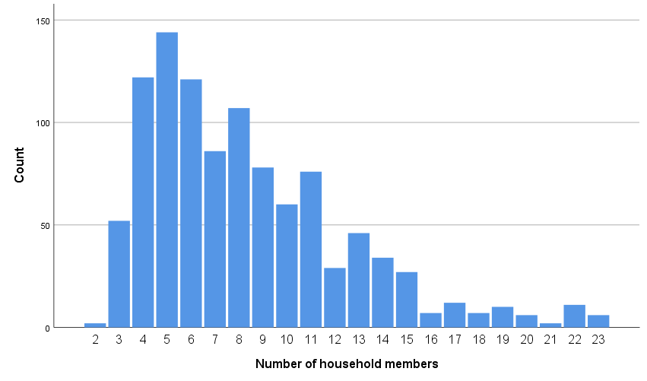

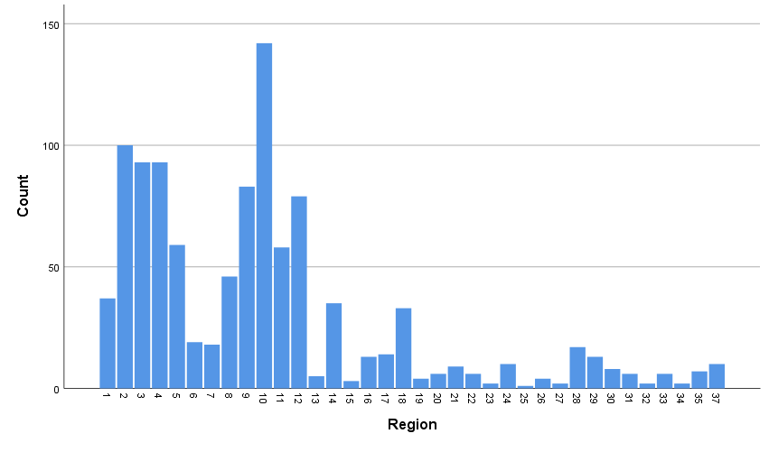

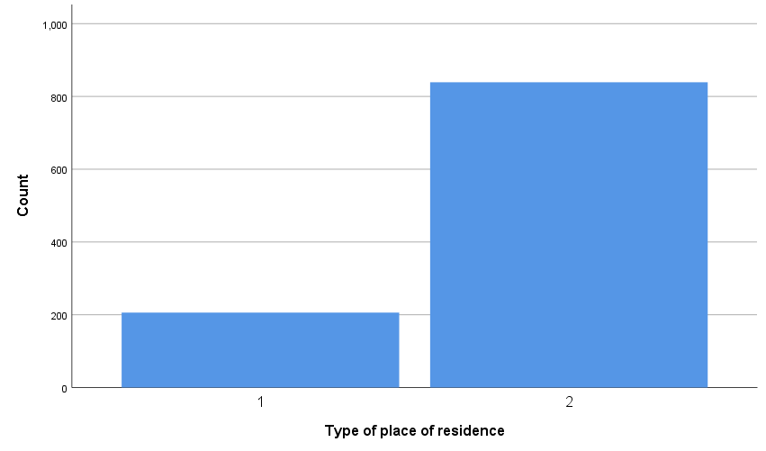

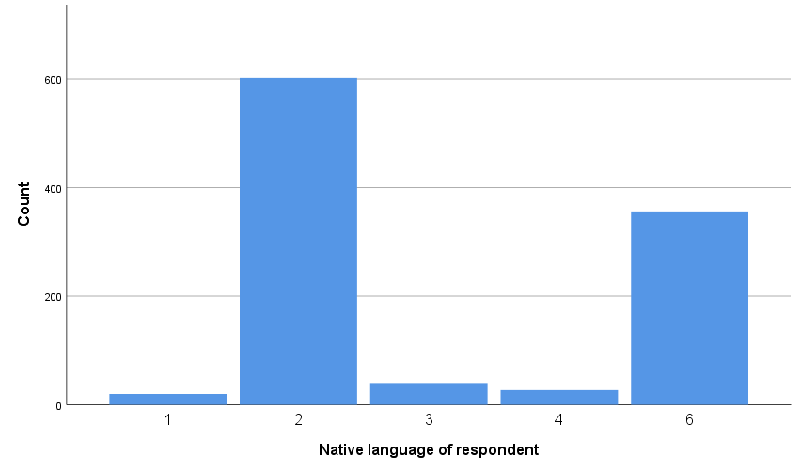

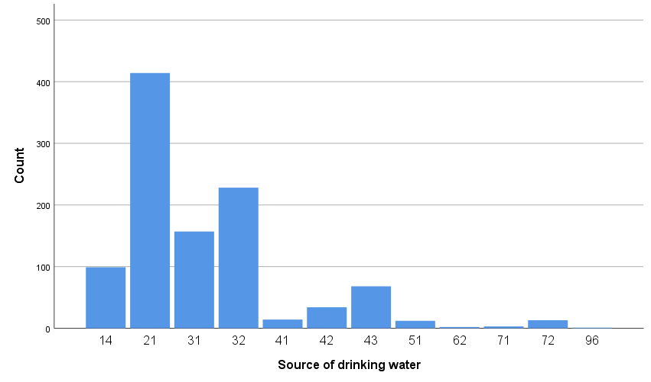

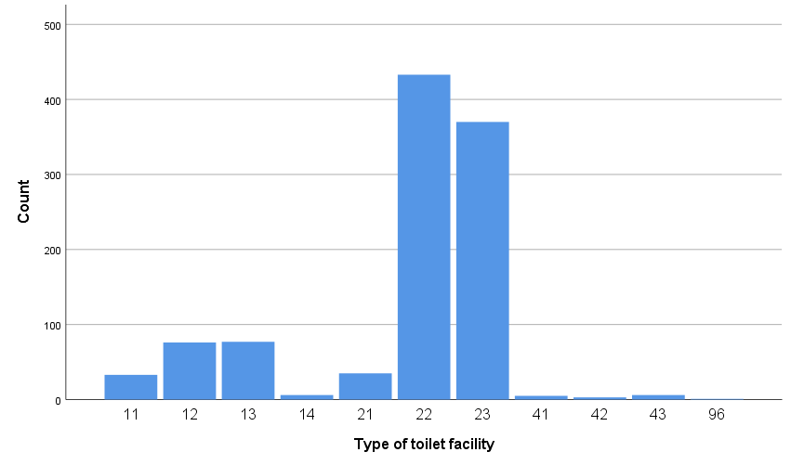

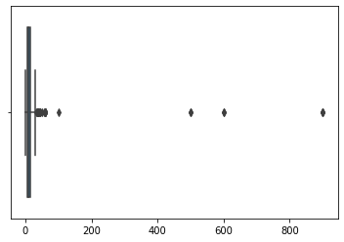

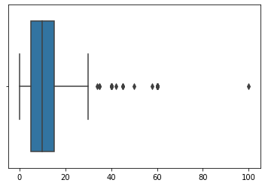

Time to get to water source (minutes)

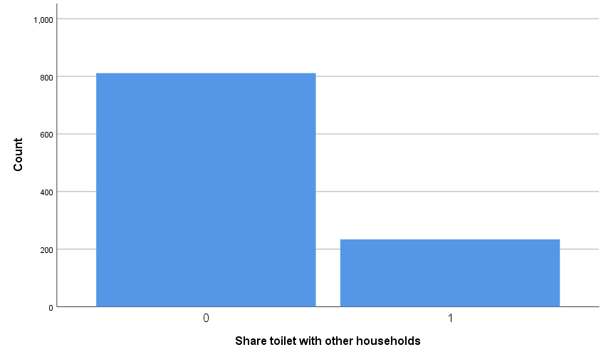

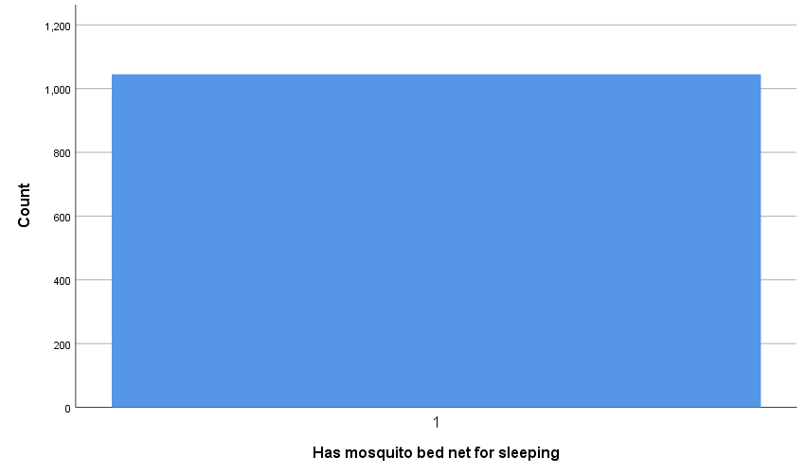

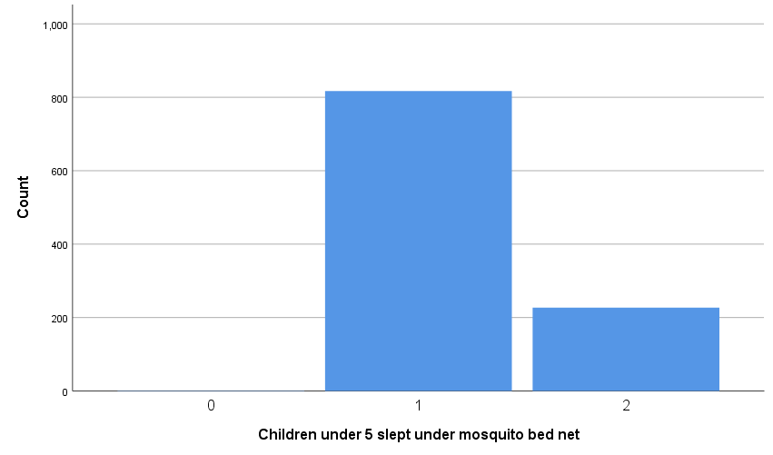

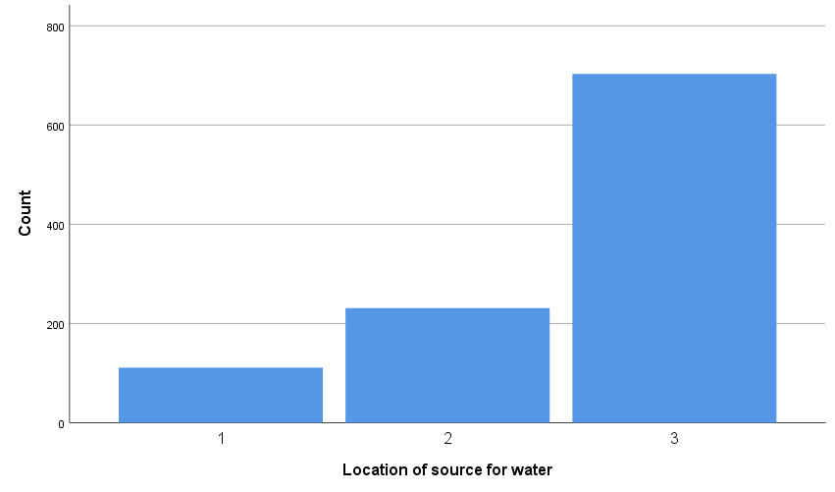

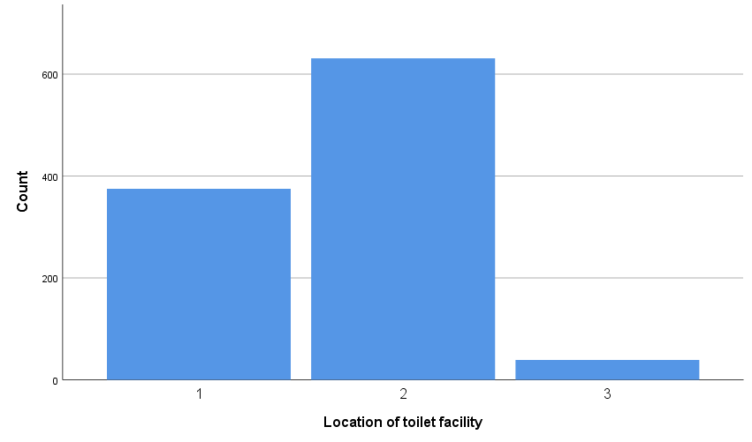

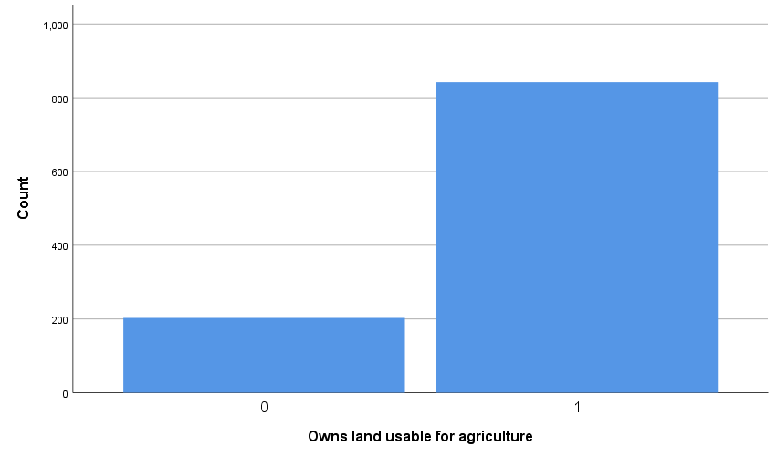

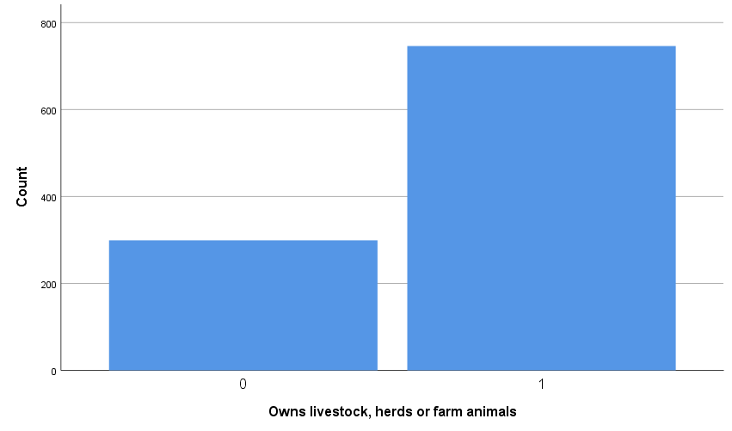

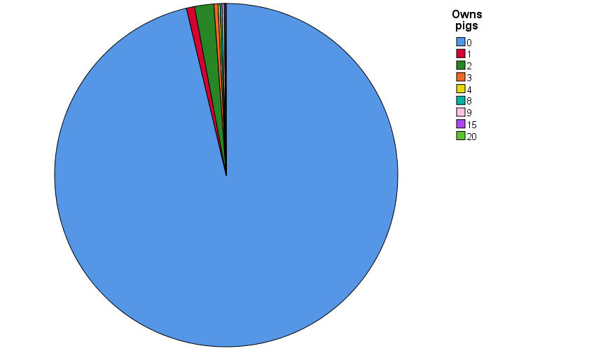

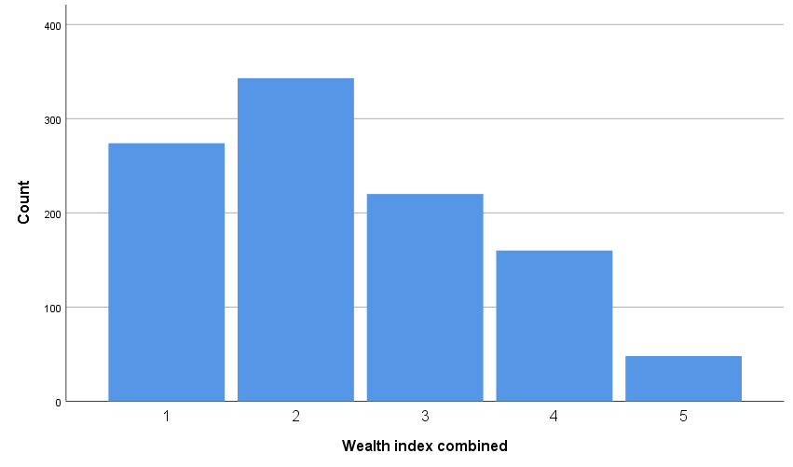

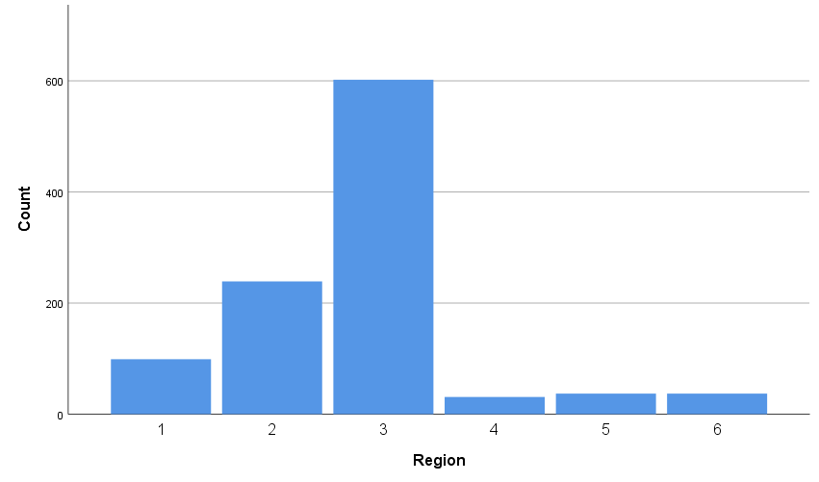

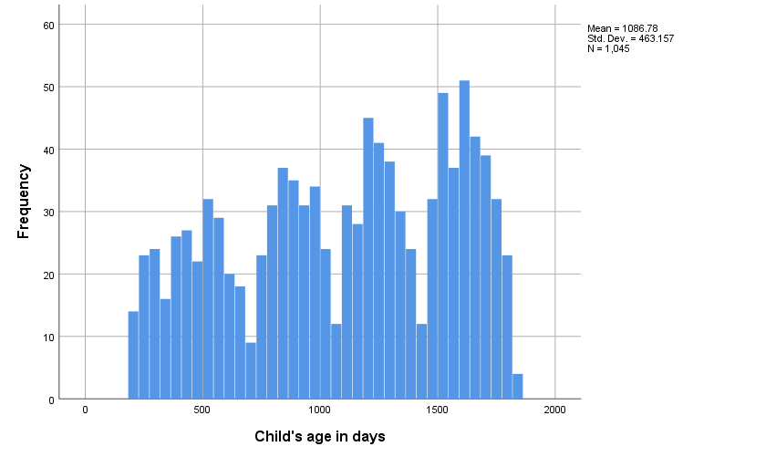

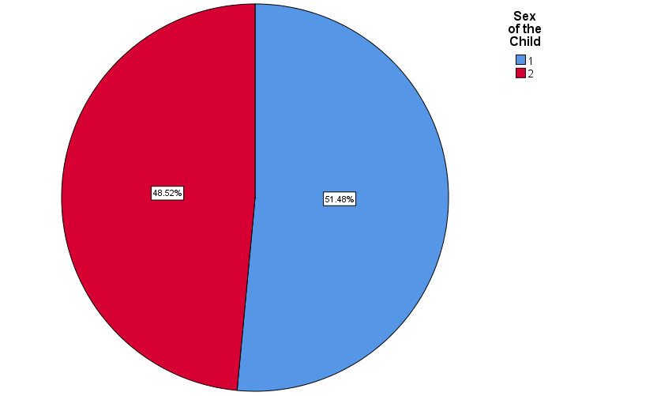

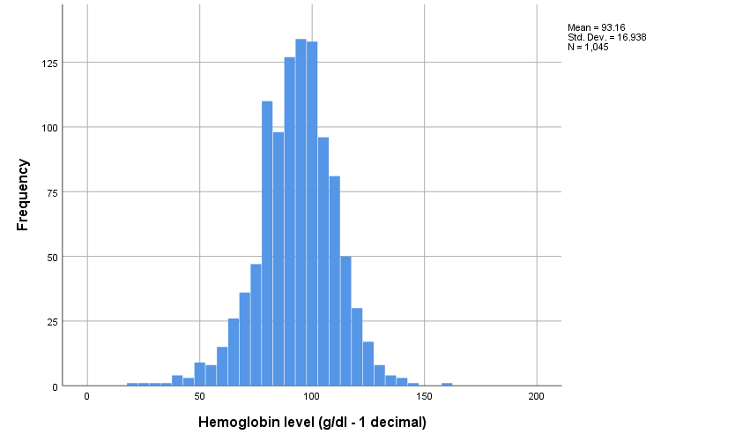

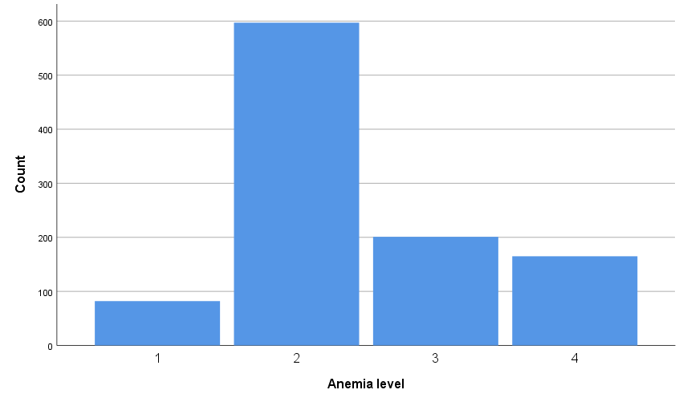

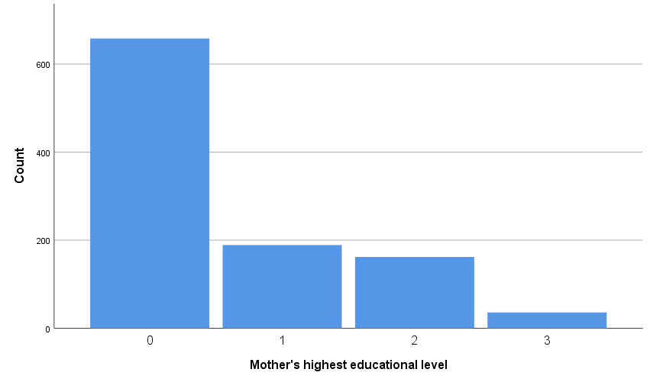

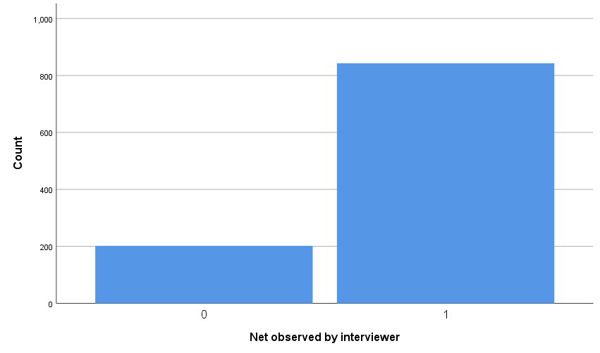

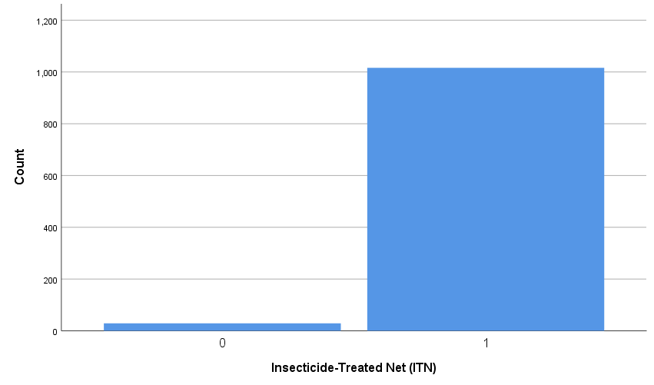

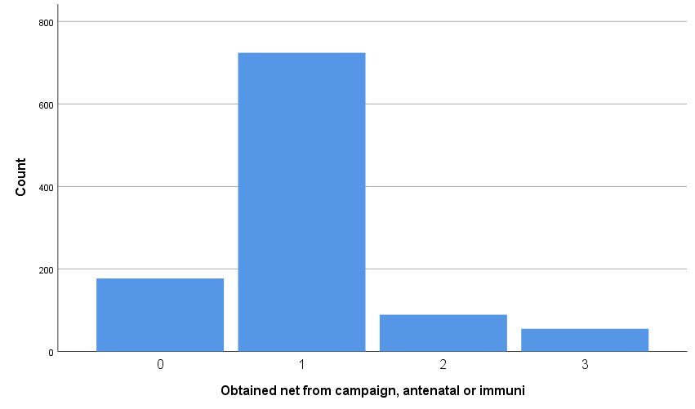

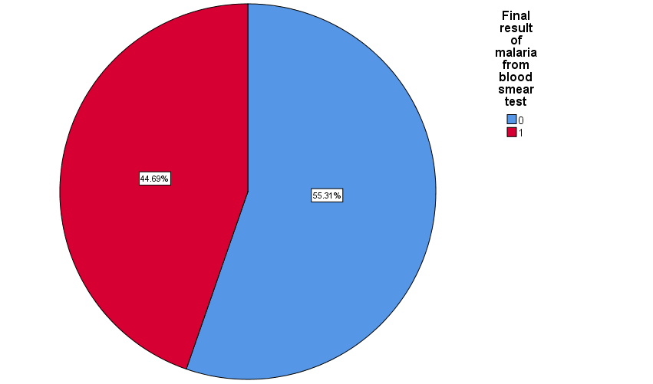

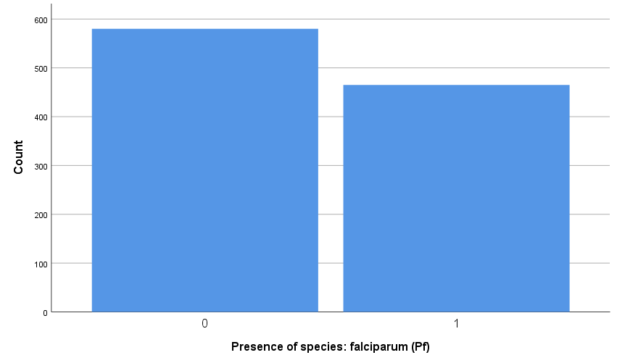

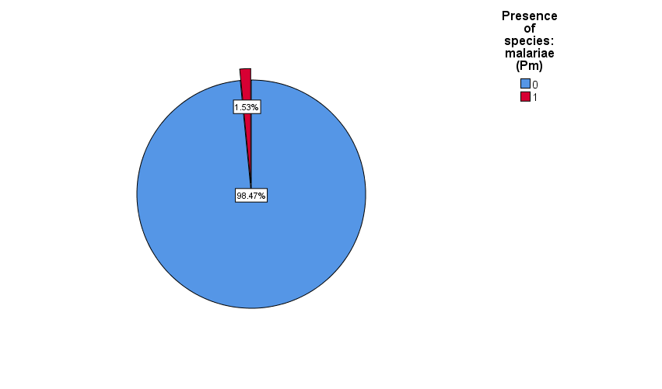

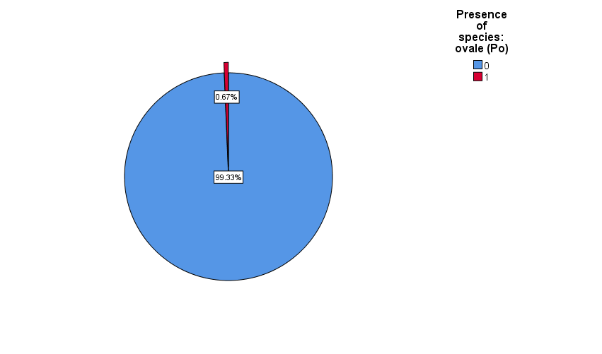

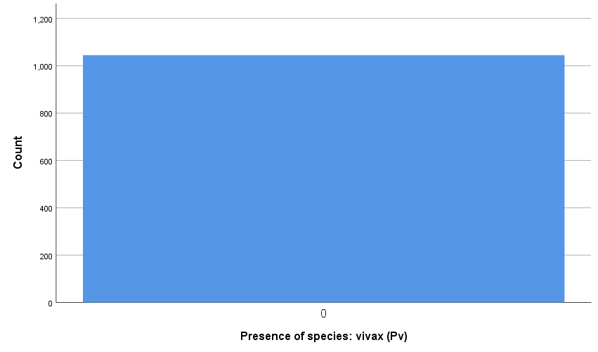

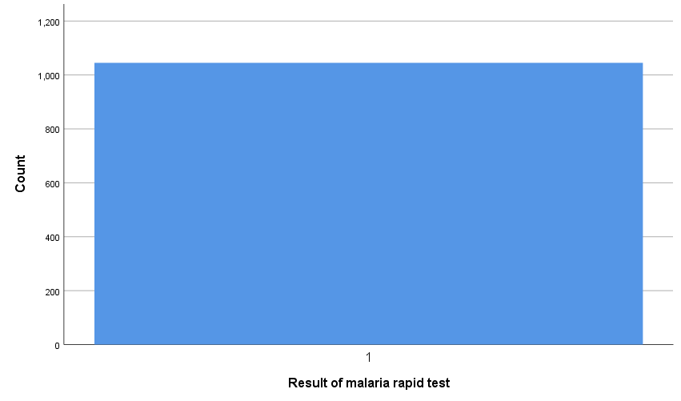

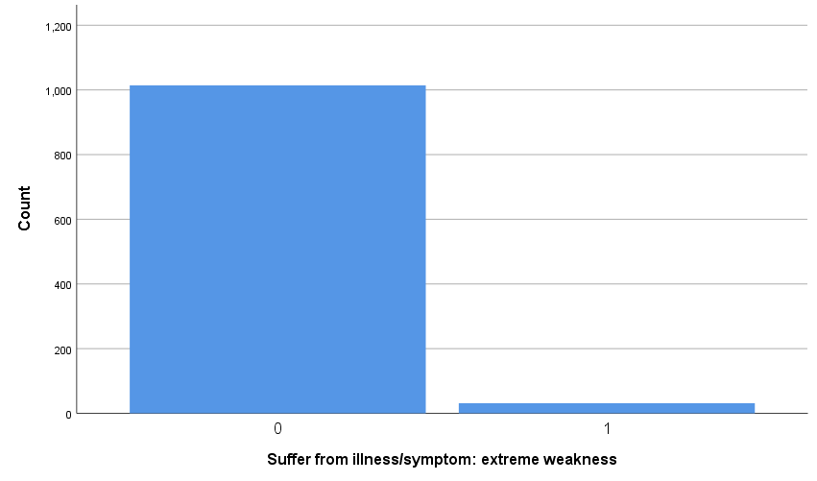

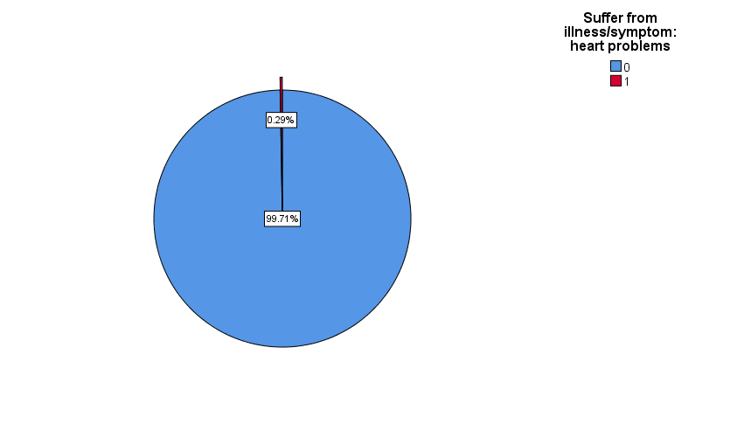

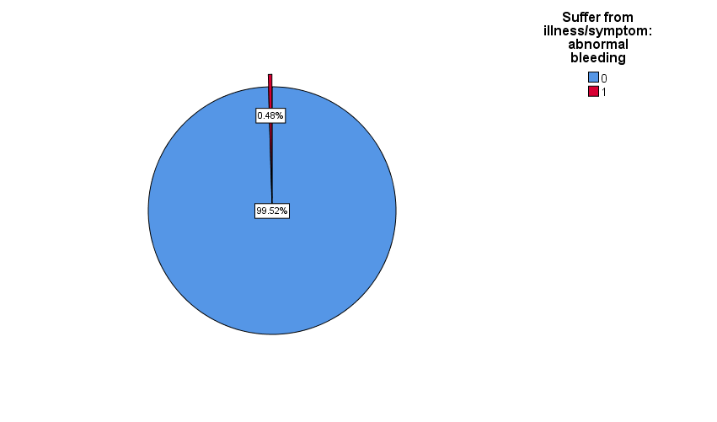

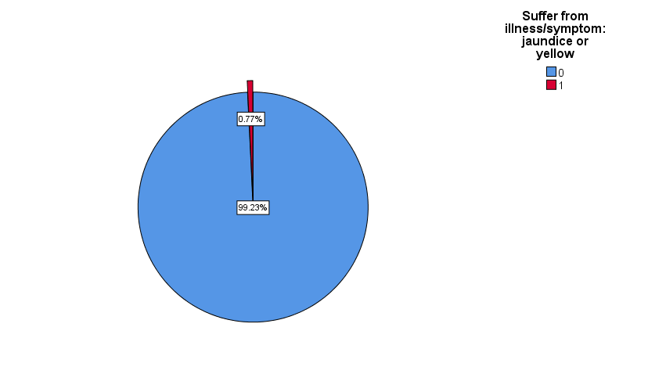

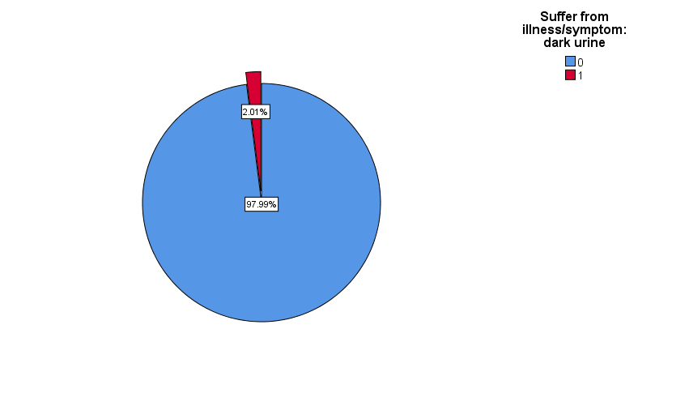

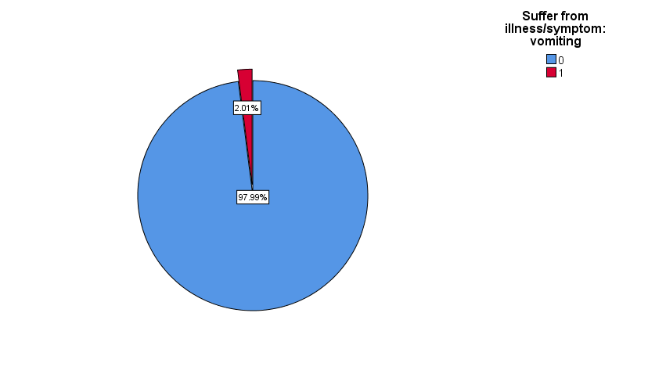

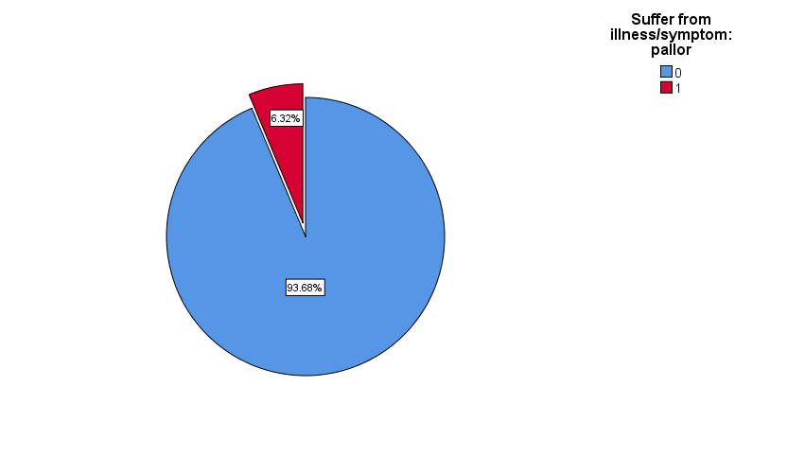

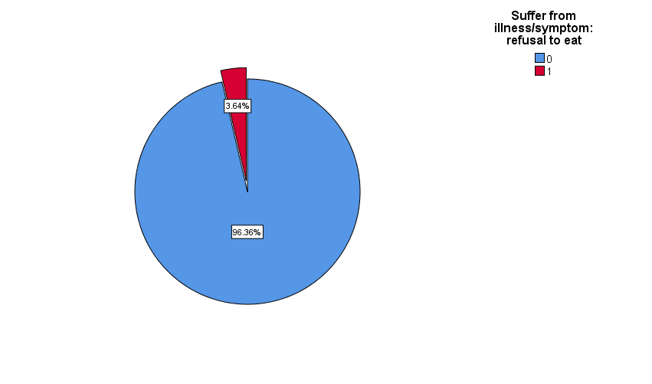

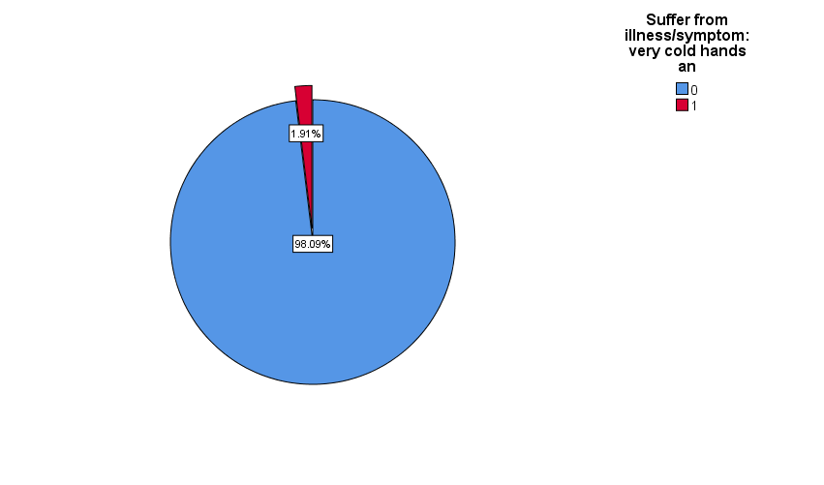

**4 Data Processing**

**4.1 Dealing with Missing Data**

In this study a root level survey data is used, and this survey is conducted by human. And missing value is obvious due to human error.

As our focus is to predict the Malaria positive/negative, so first of all whole dataset of selected features was filtered based on the available data of feature *“Final result of malaria from blood smear test” (df[(df['hml32'] == 0) | (df['hml32'] == 1)]).* Then three features “SH130 - Reason net was not used”, “HV202 - Source of non-drinking water” and “HML23 - Place where net was obtained” were eliminated due to data unavailability (very small amount of data were available after filtering).

After the first filtering five features showed the existence of missing values within them. So, gradually five filtering were done to remove missing values.

Filters for removing missing values:

a. df[(df['hml37l'] == 0) | (df['hml37l'] == 1)]

b. df[(df['hml22'] == 0) | (df['hml22'] == 1) | (df['hml22'] == 2) | (df['hml22'] == 3)]

c. df[(df['hv225'] == 0) | (df['hv225'] == 1)]

d. df[(df['hc61'] == 0) | (df['hc61'] == 1) | (df['hc61'] == 2) | (df['hc61'] == 3)]

e. df[(df['hv235'] == 1) | (df['hv235'] == 2) | (df['hv235'] == 3)]

After removing missing values and eliminating some features the shape of final dataset was (1045,40) [row = 1045 and columns = 40].

**4.2 Feature Calculation**

Feature calculation was not need due to the independent* and unique characteristics of the selected features. Label encoding and data type (numerical & categorical) were defined to reduce computational cost.

* Here the word “independent” doesn’t mean statistically independent

**4.3 Relation between Predictors and Outcome**

The numerical values represented in the figures refer to the column “Values” in the Table.2

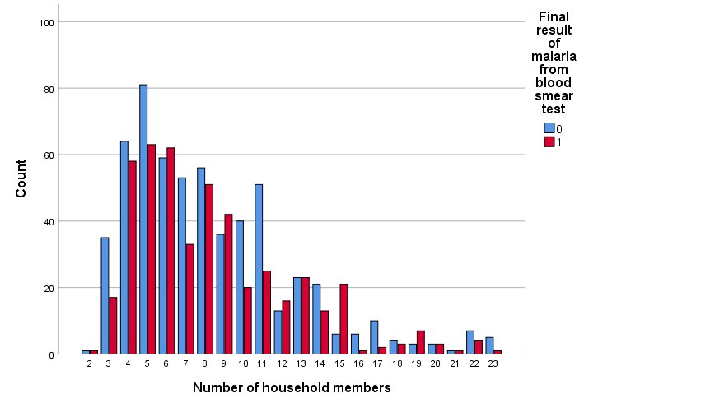

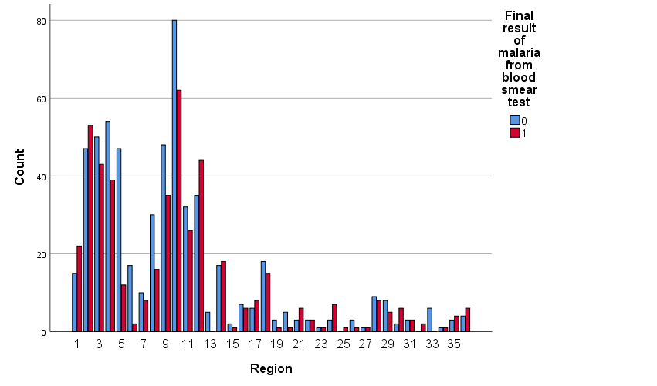

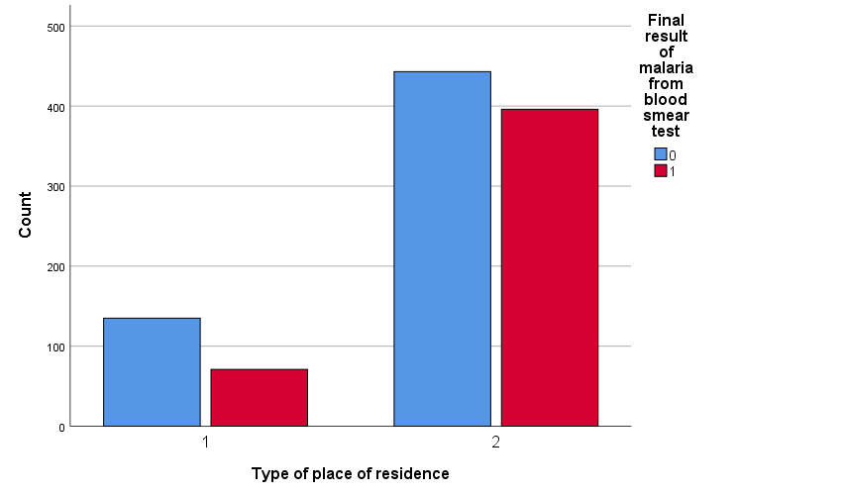

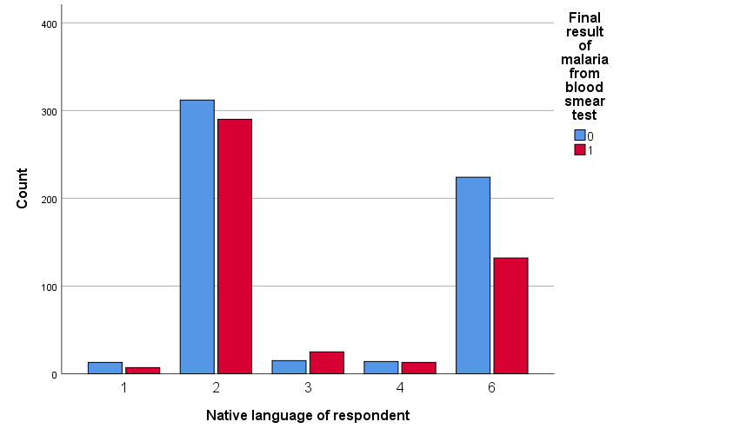

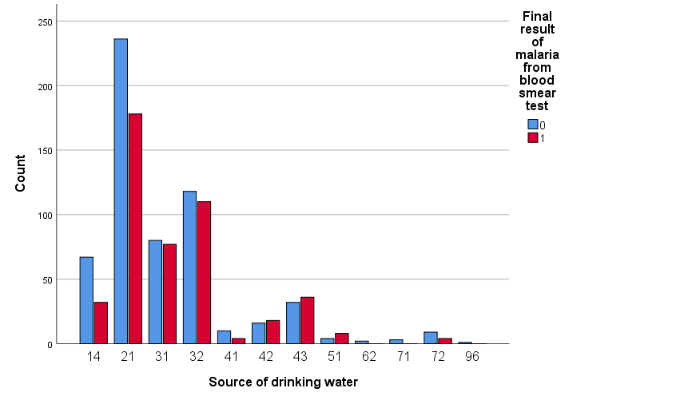

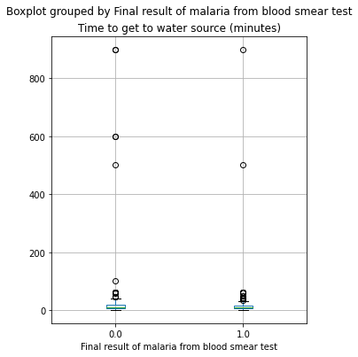

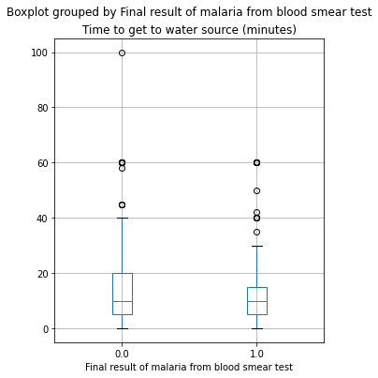

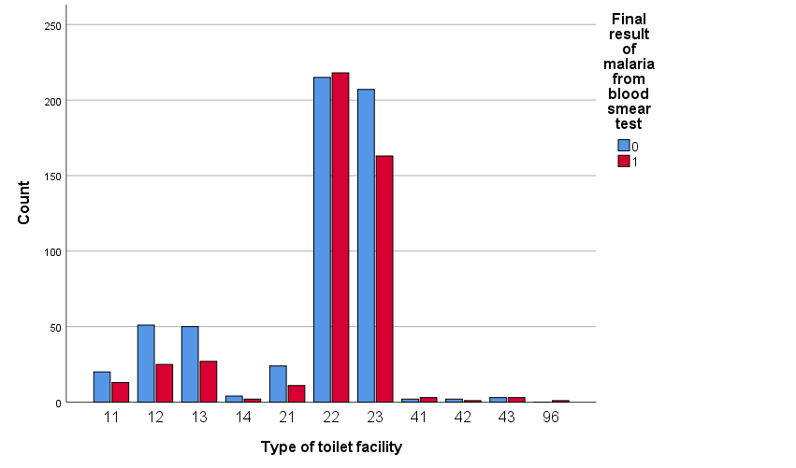

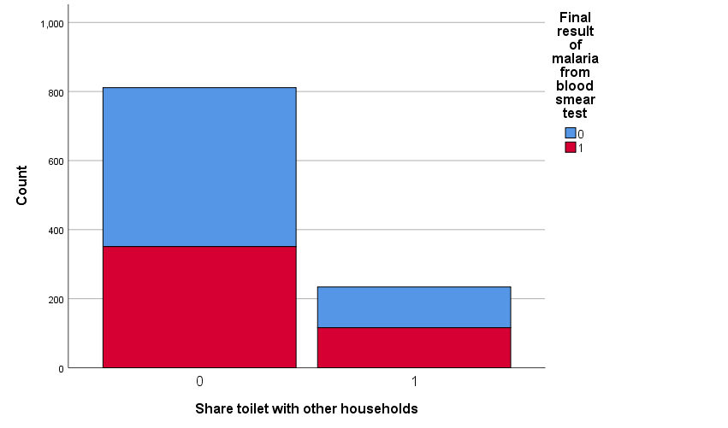

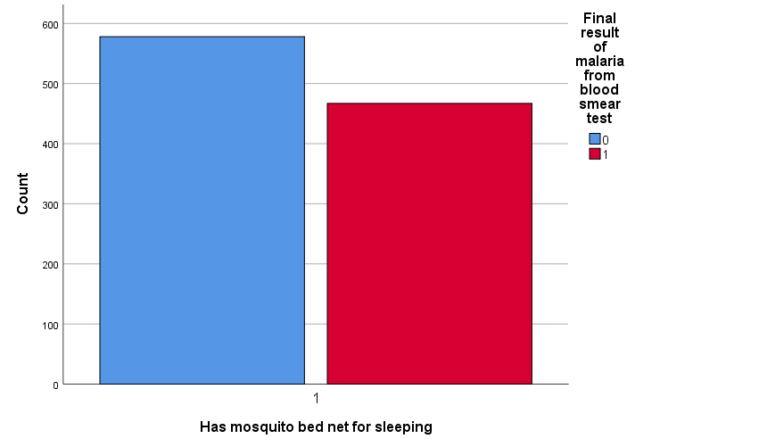

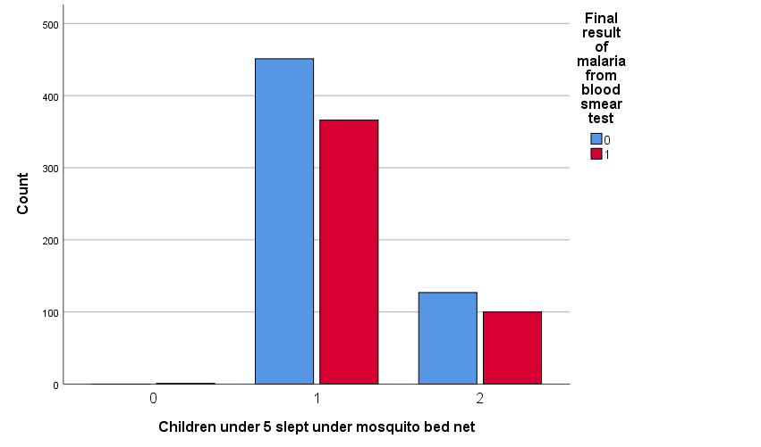

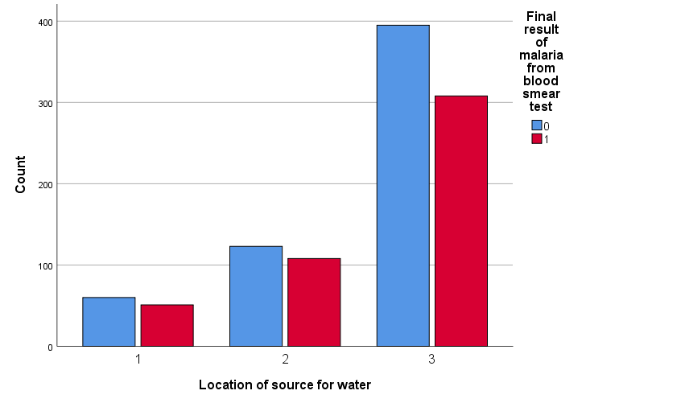

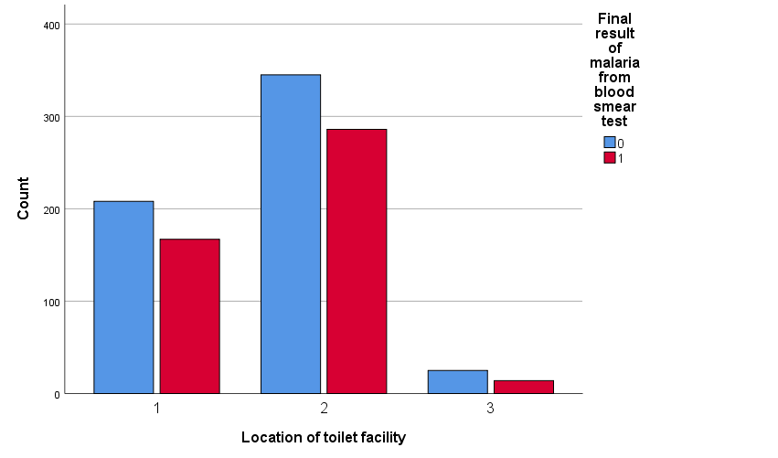

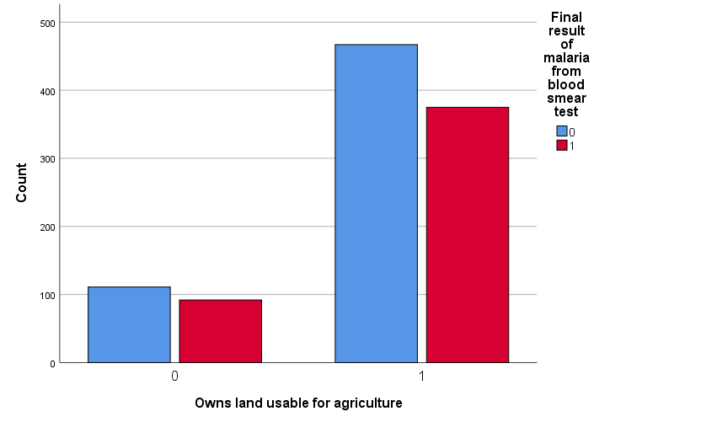

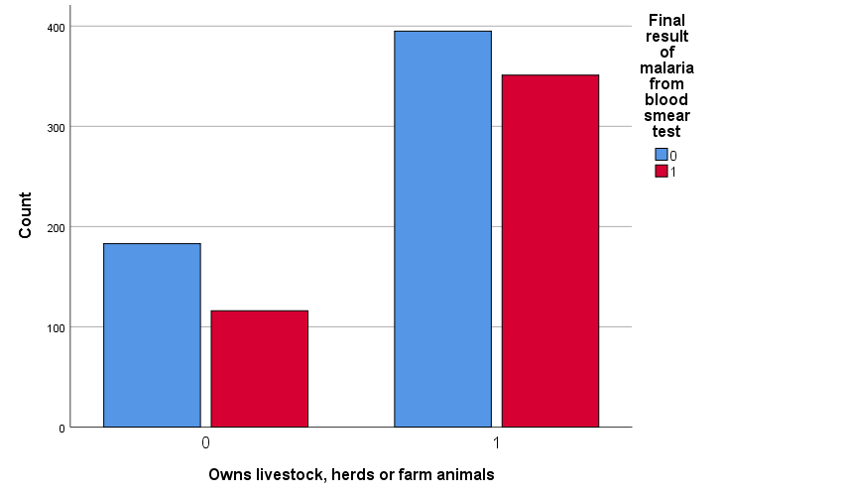

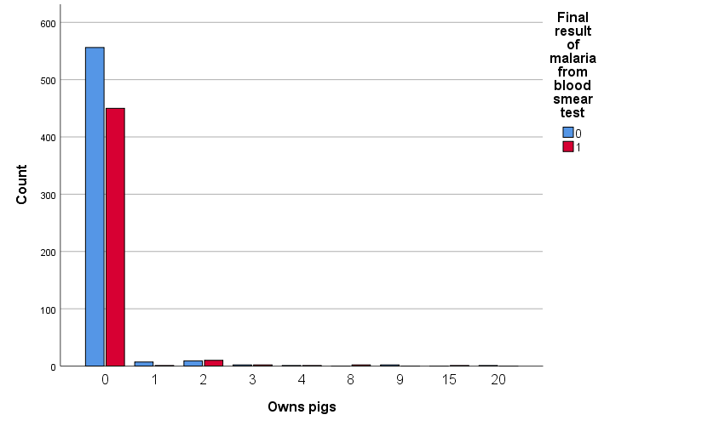

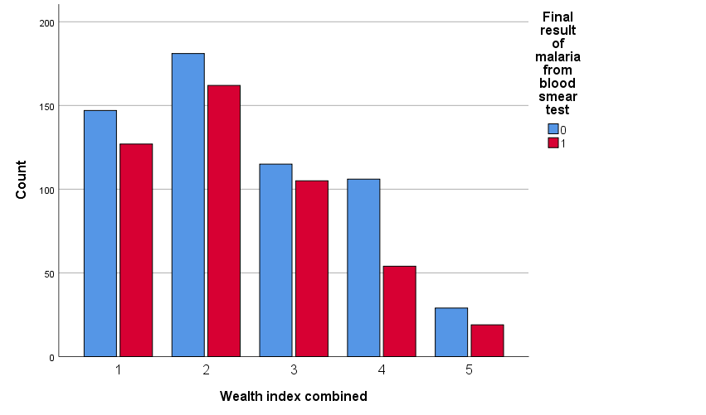

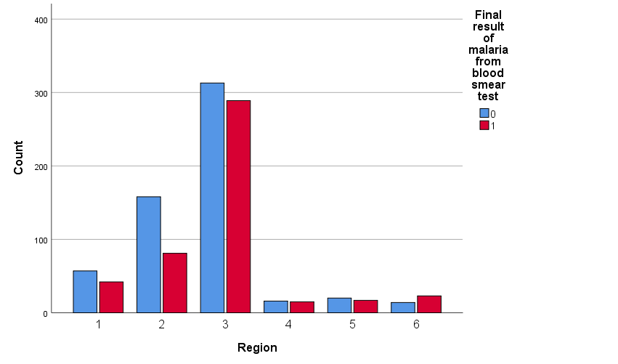

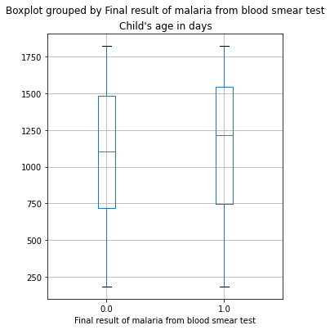

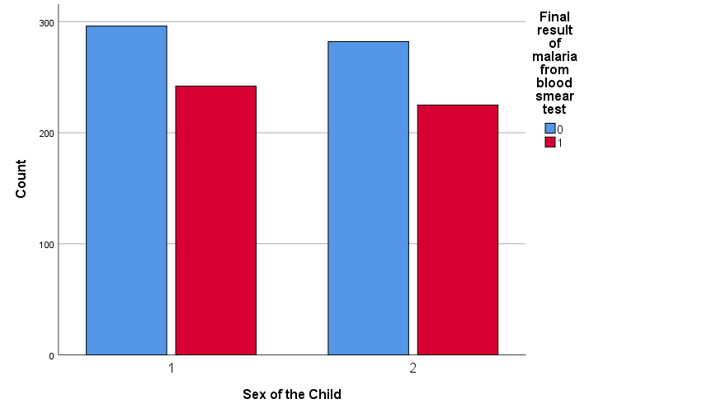

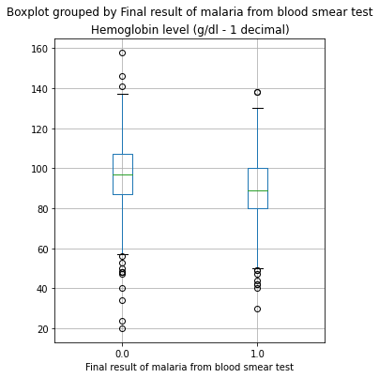

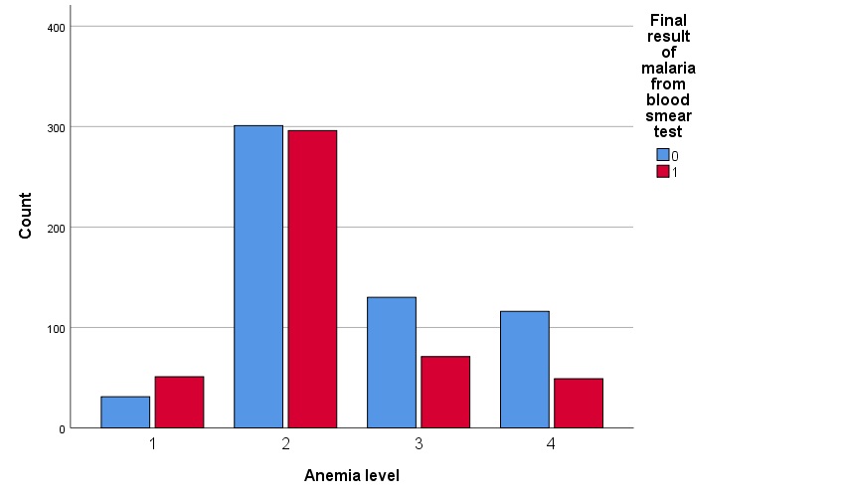

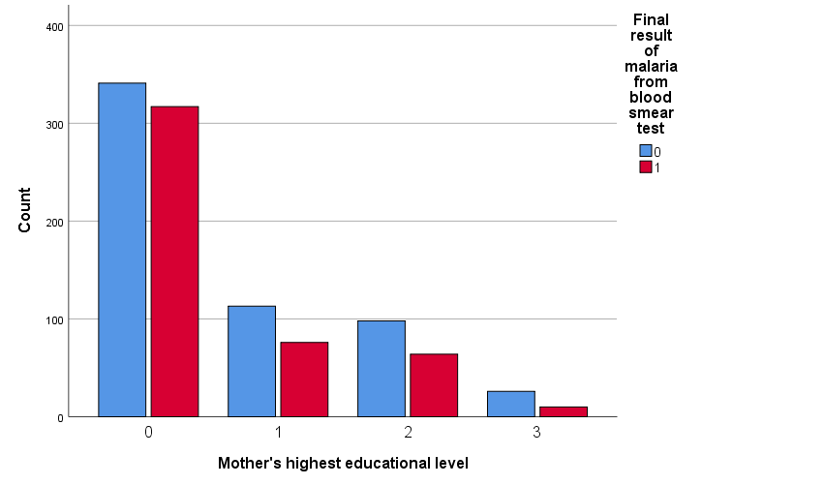

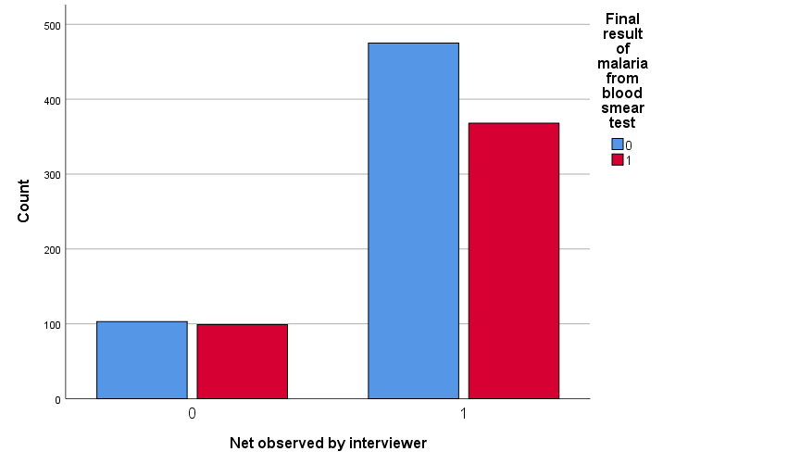

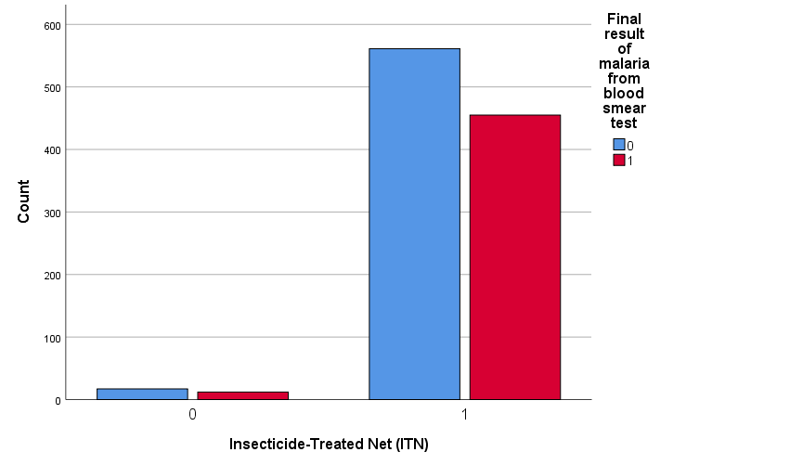

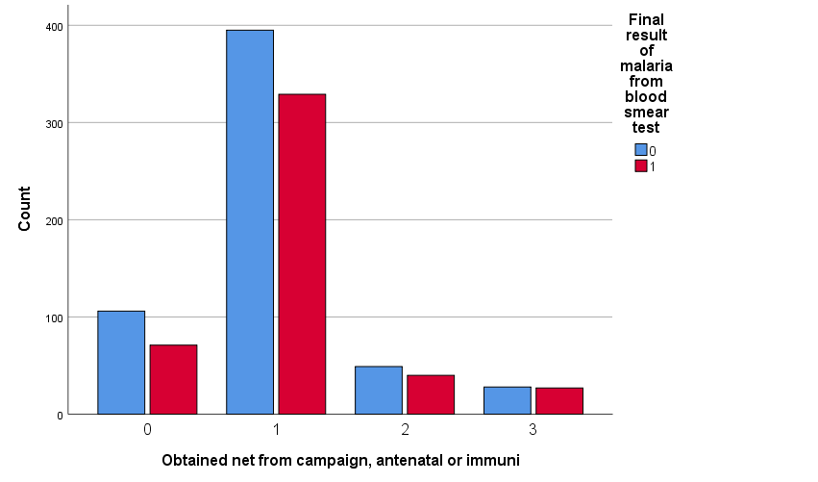

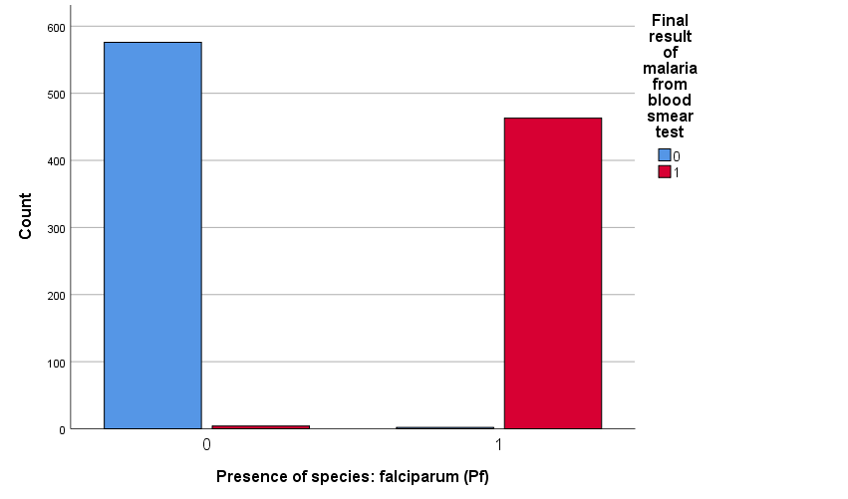

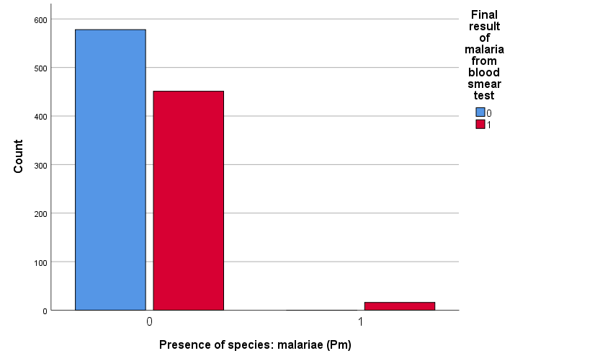

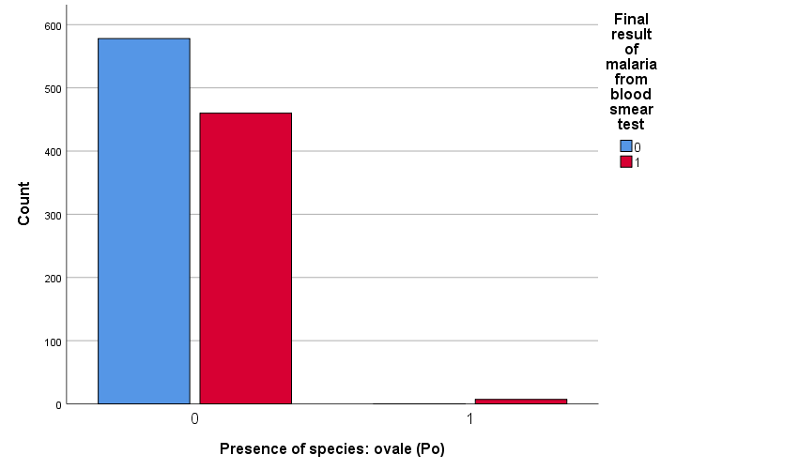

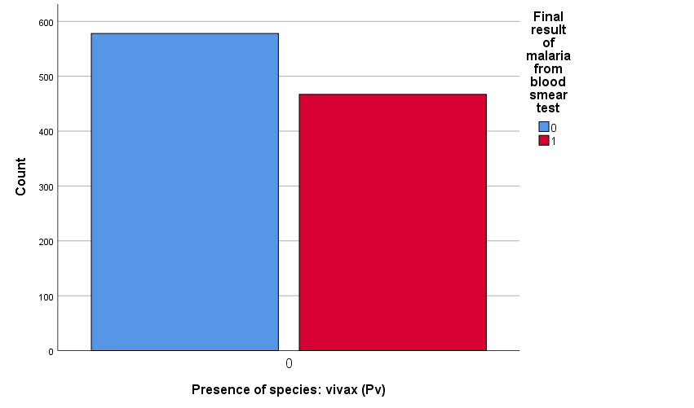

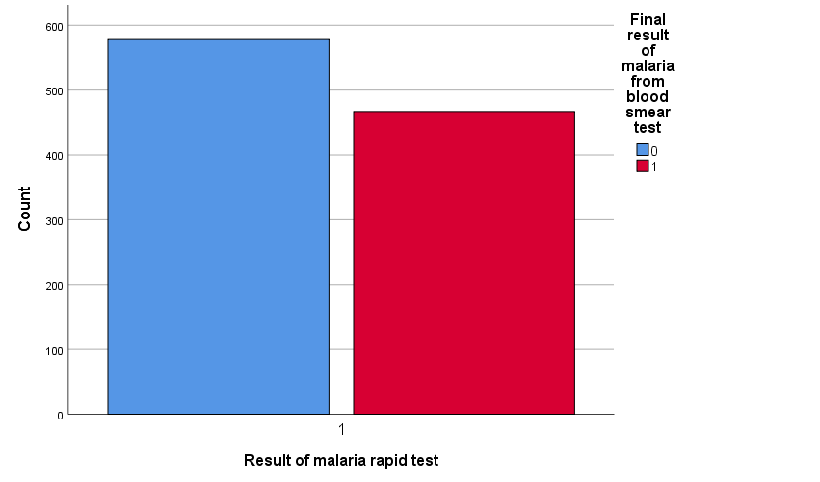

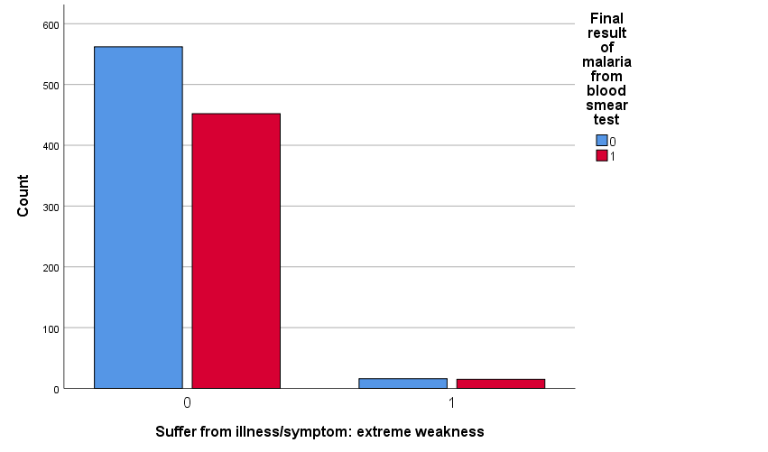

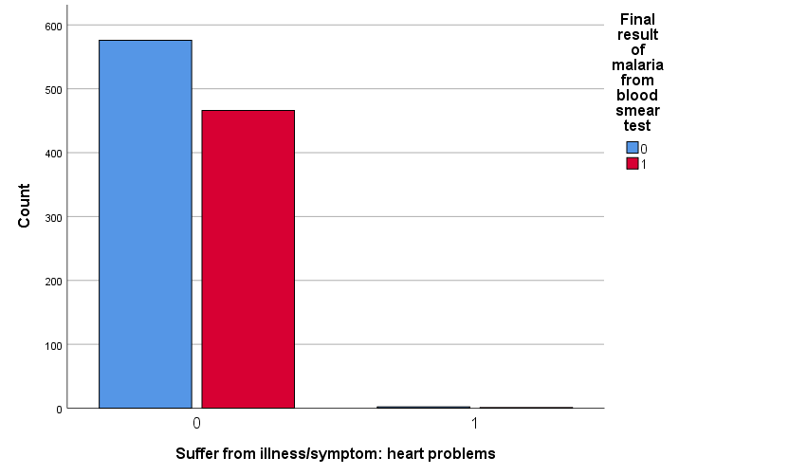

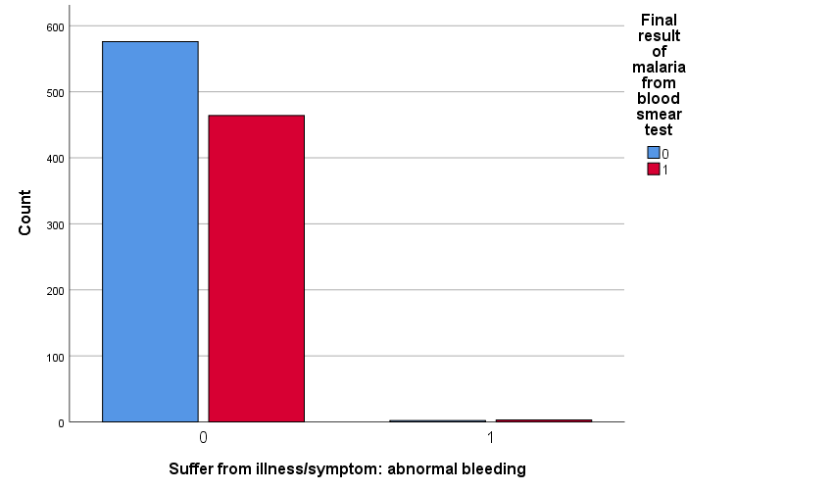

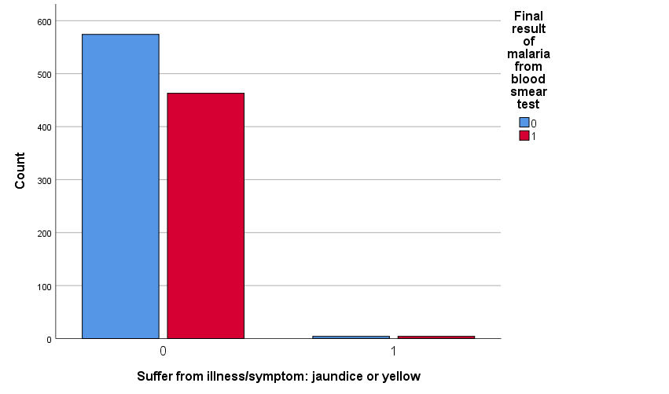

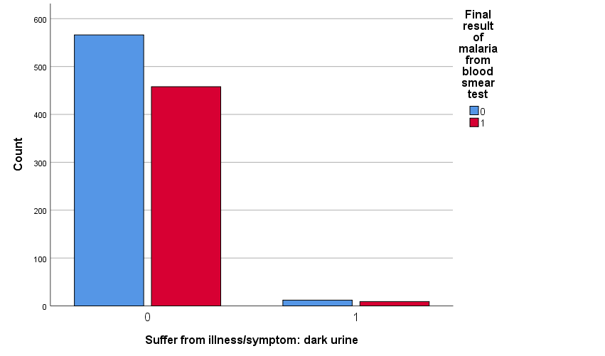

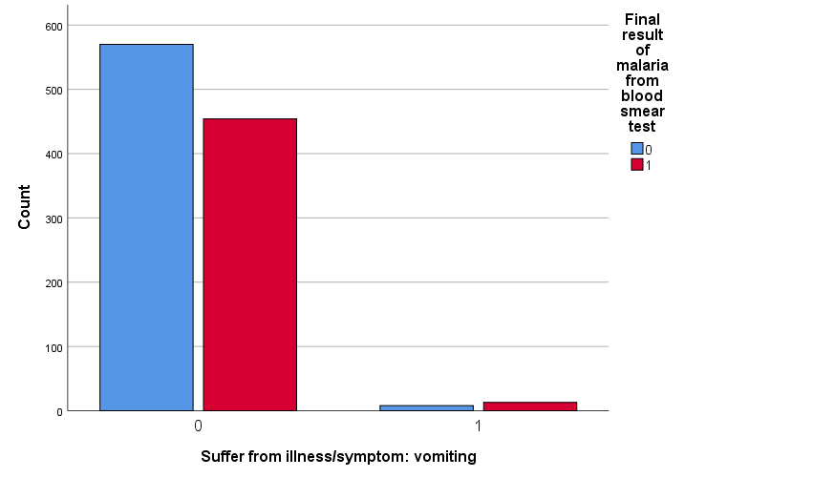

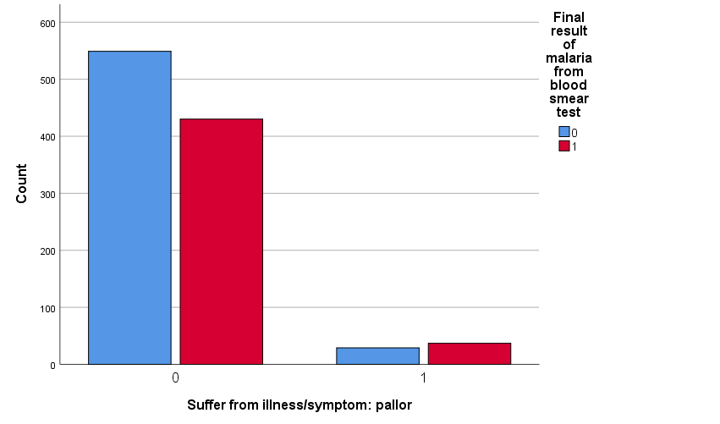

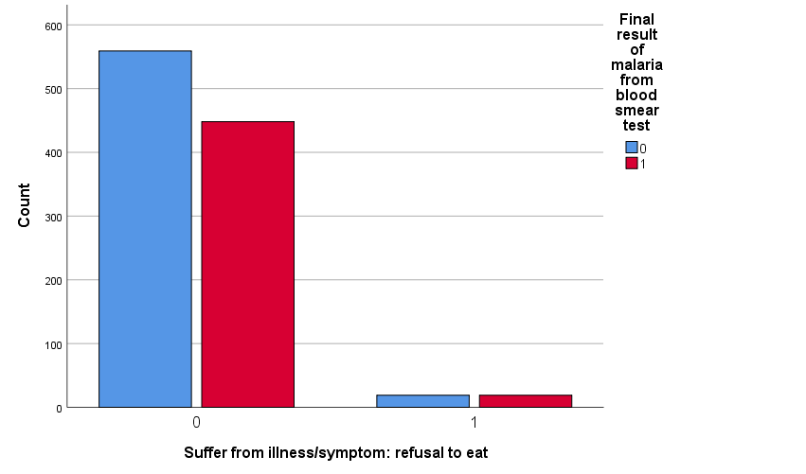

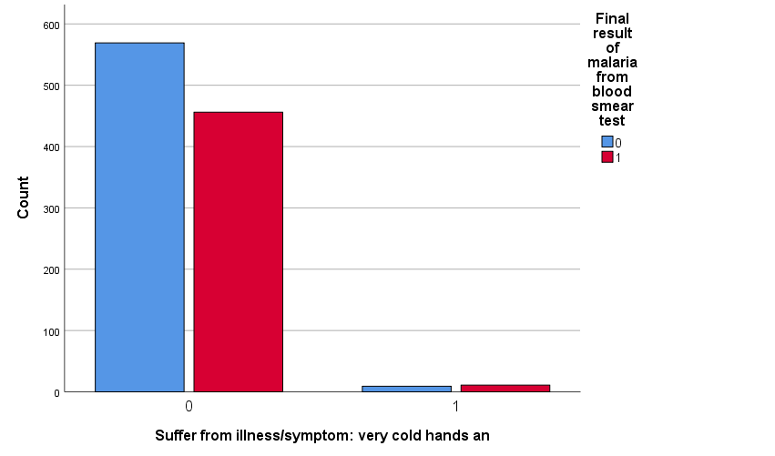

**4.4 Correlation Matrix**

From section 4.2 distribution of features we found that features 'Has mosquito bed net for sleeping', "Presence of species: vivax (Pv)", "Result of malaria rapid test" have only single values which will not play any role in our further analysis. At this stage we will eliminate there three features.

Table.4 Correlation Matrix: Chi-Square Test for Categorical vs Categorical and Kruskal-Wallis H (K-H) Test for Numerical vs Categorical features

| **SL. No.** | **Features** | **Chi-square/ K-H** | **p-value** | **dof** | **Dtype** | **Decision** |
| --- | --- | --- | --- | --- | --- | --- |
| 1 | Number of household members | 1620.872780 | 0.000000e+00 | 1.0 | int64 | Yes |
| 2 | SubRegion | 62.151036 | 3.153244e-03 | 35.0 | category | Yes |
| 3 | Type of place of residence | 10.339342 | 1.302244e-03 | 1.0 | category | Yes |
| 4 | Native language of respondent | 17.321305 | 1.673913e-03 | 4.0 | category | Yes |
| 5 | Source of drinking water | 21.469956 | 2.881652e-02 | 11.0 | category | Yes |
| 6 | Time to get to water source (minutes) | 1591.066796 | 0.000000e+00 | 1.0 | int64 | Yes |
| 7 | Type of toilet facility | 17.943525 | 5.592380e-02 | 10.0 | category | No |
| 8 | Share toilet with other households | 2.660290 | 1.028820e-01 | 1.0 | category | No |
| 9 | Children under 5 slept under mosquito bed net | 1.278780 | 5.276140e-01 | 2.0 | category | No |
| 10 | Location of source for water | 0.687799 | 7.090000e-01 | 2.0 | category | No |
| 11 | Location of toilet facility | 1.326406 | 5.151985e-01 | 2.0 | category | No |
| 12 | Owns land usable for agriculture | 0.015100 | 9.022006e-01 | 1.0 | category | No |
| 13 | Owns livestock, herds or farm animals | 5.555287 | 1.842495e-02 | 1.0 | category | Yes |
| 14 | Owns pigs | 445.052429 | 8.607102e-99 | 1.0 | int64 | Yes |
| 15 | Wealth index combined | 10.275718 | 3.603073e-02 | 4.0 | category | Yes |
| 16 | Region | 18.924853 | 1.985076e-03 | 5.0 | category | Yes |
| 17 | Child's age in days | 1619.058802 | 0.000000e+00 | 1.0 | int64 | Yes |
| 18 | Sex of the Child | 0.017852 | 8.937107e-01 | 1.0 | category | No |
| 19 | Hemoglobin level (g/dl - 1 decimal) | 1619.153732 | 0.000000e+00 | 1.0 | float64 | Yes |
| 20 | Anemia level | 38.083649 | 2.713533e-08 | 3.0 | category | Yes |
| 21 | Mother's highest educational level | 10.695928 | 1.348904e-02 | 3.0 | category | Yes |
| 22 | Net observed by interviewer | 1.680885 | 1.948069e-01 | 1.0 | category | No |
| 23 | Insecticide-Treated Net (ITN) | 0.030337 | 8.617287e-01 | 1.0 | category | No |
| 24 | Obtained net from campaign, antenatal or immune | 2.099025 | 5.521101e-01 | 3.0 | category | No |
| 25 | Final result of malaria from blood smear test | 1040.958270 | 2.246937e-228 | 1.0 | category | Yes |
| 26 | Presence of species: falciparum (Pf) | 1016.876105 | 3.855134e-223 | 1.0 | category | Yes |
| 27 | Presence of species: malariae (Pm) | 17.902631 | 2.324995e-05 | 1.0 | category | Yes |
| 28 | Presence of species: ovale (Po) | 6.614922 | 1.011278e-02 | 1.0 | category | Yes |
| 29 | Suffer from illness/symptom: extreme weakness | 0.056198 | 8.126090e-01 | 1.0 | category | No |
| 30 | Suffer from illness/symptom: heart problems | 0.000000 | 1.000000e+00 | 1.0 | category | No |
| 31 | Suffer from illness/symptom: abnormal bleeding | 0.057332 | 8.107642e-01 | 1.0 | category | No |
| 32 | Suffer from illness/symptom: jaundice or yellow | 0.000000 | 1.000000e+00 | 1.0 | category | No |
| 33 | Suffer from illness/symptom: dark urine | 0.000000 | 1.000000e+00 | 1.0 | category | No |
| 34 | Suffer from illness/symptom: vomiting | 1.908041 | 1.671810e-01 | 1.0 | category | No |
| 35 | Suffer from illness/symptom: pallor | 3.210897 | 7.314935e-02 | 1.0 | category | No |
| 36 | Suffer from illness/symptom: refusal to eat | 0.254647 | 6.138218e-01 | 1.0 | category | No |
| 37 | Suffer from illness/symptom: very cold hands an | 0.503297 | 4.780551e-01 | 1.0 | category | No |

After eliminating the features with p-value < 0.05, features on Table.5 will be used to implement ML algorithms

Table.5 Features having p-value < 0.05

| **SL. No.** | **Features** | **Chi-Square/ K-H** | **p-value** | **Dof** | **Dtype** | **Decision** |
| --- | --- | --- | --- | --- | --- | --- |
| 1 | Number of household members | 1620.872780 | 0.000000e+00 | 1.0 | int64 | True |
| 2 | SubRegion | 62.151036 | 3.153244e-03 | 35.0 | category | True |
| 3 | Region | 18.924853 | 1.985076e-03 | 5.0 | category | True |
| 4 | Type of place of residence | 10.339342 | 1.302244e-03 | 1.0 | category | True |
| 5 | Native language of respondent | 17.321305 | 1.673913e-03 | 4.0 | category | True |
| 6 | Source of drinking water | 21.469956 | 2.881652e-02 | 11.0 | category | True |
| 7 | Time to get to water source (minutes) | 1591.066796 | 0.000000e+00 | 1.0 | int64 | True |
| 8 | Owns livestock, herds or farm animals | 5.555287 | 1.842495e-02 | 1.0 | category | True |
| 9 | Owns pigs | 445.052429 | 8.607102e-99 | 1.0 | int64 | True |
| 10 | Wealth index combined | 10.275718 | 3.603073e-02 | 4.0 | category | True |
| 11 | Child's age in days | 1619.058802 | 0.000000e+00 | 1.0 | int64 | True |
| 12 | Hemoglobin level (g/dl - 1 decimal) | 1619.153732 | 0.000000e+00 | 1.0 | float64 | True |
| 13 | Anemia level | 38.083649 | 2.713533e-08 | 3.0 | category | True |
| 14 | Mother's highest educational level | 10.695928 | 1.348904e-02 | 3.0 | category | True |
| 15 | Final result of malaria from blood smear test | 1040.958270 | 2.246937e-228 | 1.0 | category | True |
| 16 | Presence of species: falciparum (Pf) | 1016.876105 | 3.855134e-223 | 1.0 | category | True |
| 17 | Presence of species: malariae (Pm) | 17.902631 | 2.324995e-05 | 1.0 | category | True |
| 18 | Presence of species: ovale (Po) | 6.614922 | 1.011278e-02 | 1.0 | category | True |

**5 Analytical Results**

**5.1.1 Model Implementation**

The dataset used in this study has dimensionality of 70428 observations and 225 features. After cleaning, filtering, preprocessing and statistical analysis (discussed in Section 4) we got high quality clean dataset (DS1: 1045 observations and 17 predictor features and one target feature). To enlarge the dataset, we have implemented Random Oversampling (ROS) model which enlarged the dataset.

In original dataset (DS1) the percentage of malaria positive/negative ratio is 55% negative & 45% negative. For ROS we also followed this positive/negative ratio of DS1. The newly generated ROS dataset (DS2) has 5500 negative observations and 4500 positive observations.

In this study two traditional machine learning model Logistic Regression (LR) & Decision Tree (DT) and one AutoML framework H2O AutoML were implemented on both datasets DS1 and DS2. For training, testing and validation datasets were split as 80%, 10% and 10% respectively.

**5.1.2 Model Diagnostics**

***Random Oversampling***

Random Oversampling (ROS) [28] was done with the help of *imblearn* a python package. Here *RandomOverSampler()* method was called with sampling strategy (0 = 5500 and 1 = 4500). ROS uses Random Forest algorithm in its backed to enlarge the existing dataset.

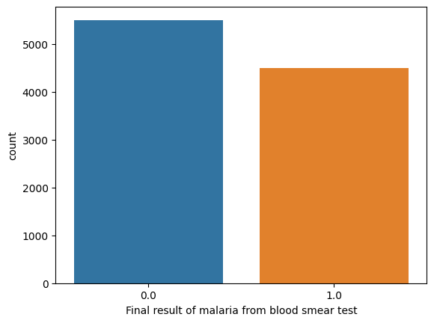

Fig.5.1 Random Oversampled Dataset (DS2) target column value count

***Logistic Regression***

Firstly Logistic Regression (LR) was implemented as ML model. In this study hyperparameter tuning was done. Here regularization (penalty) *“l2”* was set with solver *“newton-cholesky”* and max iteration *“1000”*. 10-fold cross-validation was done.

***Decision Tree***

The second model was Decision Tree (DT). Initially the DT model was trained with default parameters to find the optimum pruning with cost complexity pruning method. By this we found the below graph.

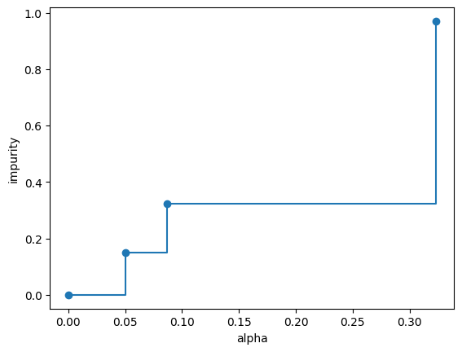

Fig.5.2 impurity vs alpha (default hyperparameter)

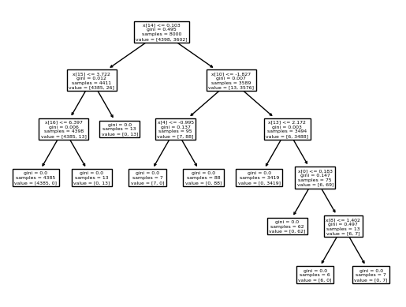

Fig.5.3 Tree expansion with default hyperparameters (overfitted tree)

Then DT was implemented with hyperparameter max depth *“4”*, method used for maximum feature used for each tree was *“sqrt”* (square root of total features), splitter was set to *“random”* and pruning parameter alpha *“0.05”* from the figure “Fig: impurity vs alpha (pruning parameter)”. And also, cross-validation was done with 10-fold

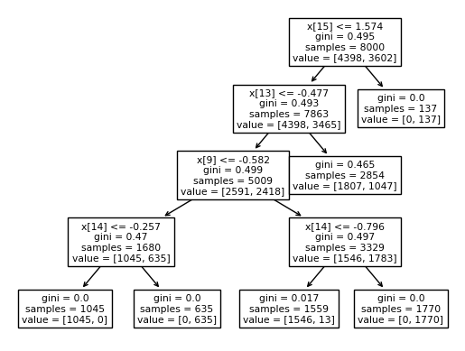

Fig.5.4 Tree expansion after fine tuning hyperparameters

***H2O AutoML***

In H2O AutoML there are hundreds of traditional, modified and new algorithms including *deep learning* models. Due to computational and time limitation we restricted the model with *max_model = 5* which means the model will give best 5 model from its framework after training and set cross-validation as 10-fold. The best part of AutoML is that, it doesn’t need any hyperparameter tuning or cleaning the dataset. By this advantages AutoML dominates the traditional ML algorithms. It also doesn’t need any ML expertise to operate. It opens a new door for those who wants to take advantages of predictive analysis (AI and ML) but don’t have expertise on ML or AI like, Health experts.

After training the H2O AutoML had given the best model. The name of the model for DS1 was Generalized Linear Model (GLM) and for DS2 was *Stacked Ensemble*. *Stacked Ensemble* model follows a stacking strategy which is given below

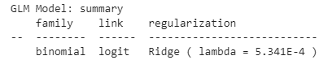

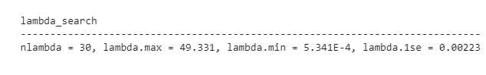

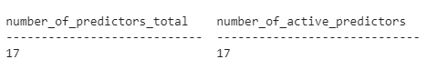

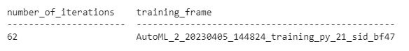

Fig.5.5 the optimum hyperparameters tuned by H2O AutoML in GLM for DS1

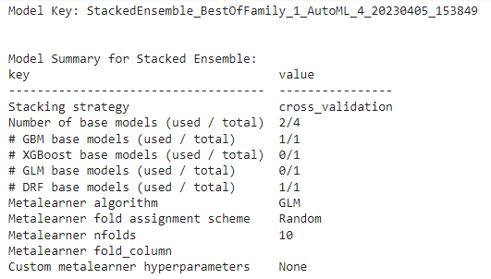

Fig.5.6 Stacking strategy (by H2O AutoML) of the best model “*Stacked Ensemble”* for DS2

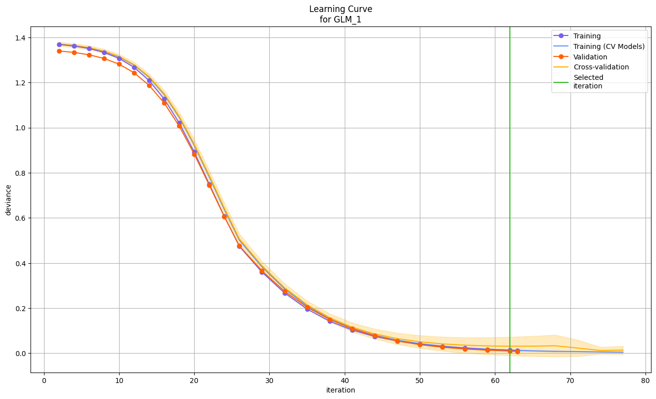

Fig.5.7 Learning Curve of GLM for DS1

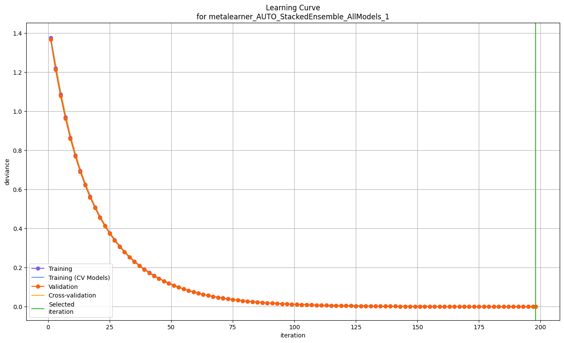

Fig.5.8 Learning Curve of Stacked Ensemble for DS2

**5.2 Model Performance**

Performance measures for all the ML models are given in below tables

Table.5 Performance measures of Logistic Regression (LR) for DS1

|  |  |  |  |  |  |  |  |
| --- | --- | --- | --- | --- | --- | --- | --- |
| **LR** | **MAE** | **RMSE** | **R2** | **Precision** | **Recall** | **f1_score** | **Accuracy** |
| **Train** | 0.007177 | 0.084717 | 0.971112 | 0.994778 | 0.989610 | 0.992188 | 0.992823 |
| **Test** | 0.000000 | 0.000000 | 1.000000 | 1.000000 | 1.000000 | 1.000000 | 1.000000 |
| **Val** | 0.000000 | 0.000000 | 1.000000 | 1.000000 | 1.000000 | 1.000000 | 1.000000 |
| **Average** | 0.002392 | 0.028239 | 0.990371 | 0.998259 | 0.996537 | 0.997396 | 0.997608 |

Table.6 Performance measures of Decision Tree (DT) for DS1

|  |  |  |  |  |  |  |  |
| --- | --- | --- | --- | --- | --- | --- | --- |
| **DT** | **MAE** | **RMSE** | **R2** | **Precision** | **Recall** | **f1_score** | **Accuracy** |
| **Train** | 0.138756 | 0.372500 | 0.441495 | 1.000000 | 0.698701 | 0.822630 | 0.861244 |
| **Test** | 0.153846 | 0.392232 | 0.365612 | 1.000000 | 0.627907 | 0.771429 | 0.846154 |
| **Val** | 0.270000 | 0.490118 | -0.158333 | 0.750000 | 0.300000 | 0.400000 | 0.730000 |
| **Average** | 0.187534 | 0.418283 | 0.216258 | 0.916667 | 0.542203 | 0.664686 | 0.812466 |

Table.7 Performance measures of H2O AutoML Generalized Linear Model (H2O_GLM) for DS1

|  |  |  |  |  |  |  |  |
| --- | --- | --- | --- | --- | --- | --- | --- |
| **H2O_GLM** | **MAE** | **RMSE** | **R2** | **Precision** | **Recall** | **f1_score** | **Accuracy** |
| **Train** | 0.000968 | 0.031109 | 0.996105 | 1.000000 | 1.000000 | 0.998689 | 0.998791 |
| **Test** | 0.000111 | 0.010544 | 0.999522 | 1.000000 | 1.000000 | 1.000000 | 1.000000 |
| **Val** | 0.002511 | 0.050115 | 0.989892 | 0.997582 | 1.000000 | 0.997375 | 0.997582 |
| **Average** | 0.001197 | 0.030589 | 0.995173 | 0.999194 | 1.000000 | 0.998688 | 0.998791 |

Table.8 Average of Table1, Table.2 and Table.3 (DS1)

|  |  |  |  |  |  |  |  |
| --- | --- | --- | --- | --- | --- | --- | --- |
| **Model** | **MAE** | **RMSE** | **R2** | **Precision** | **Recall** | **f1_score** | **accuracy** |
| **LR** | 0.0023923 | 0.0282390 | 0.99037067 | 0.9982593 | 0.9965367 | 0.9973960 | 0.9976076 |
| **DT** | 0.1875340 | 0.4182833 | 0.21625800 | 0.9166666 | 0.5422026 | 0.6646863 | 0.8124660 |
| **H2O_GLM** | 0.0011968 | 0.0305893 | 0.99517269 | 0.9991940 | 1.0000000 | 0.9986880 | 0.9987910 |

Table.9 Performance measures of LR for DS2

|  |  |  |  |  |  |  |  |
| --- | --- | --- | --- | --- | --- | --- | --- |
| **LR** | **MAE** | **RMSE** | **R2** | **Precision** | **Recall** | **f1_score** | **accuracy** |
| **Train** | 0.0016250 | 0.040311 | 0.9934350 | 0.9964040 | 1.0000000 | 0.998199 | 0.998375 |
| **Test** | 0.0020000 | 0.044721 | 0.9919540 | 0.9956900 | 1.0000000 | 0.997840 | 0.998000 |
| **Val** | 0.0030000 | 0.030000 | 0.9878030 | 0.9932830 | 1.0000000 | 0.996603 | 0.997000 |
| **average** | 0.0022083 | 0.038344 | 0.9910640 | 0.9951257 | 1.0000000 | 0.997547 | 0.997791 |

Table.10 Performance measures of DT for DS2

|  |  |  |  |  |  |  |  |
| --- | --- | --- | --- | --- | --- | --- | --- |
| **DT** | **MAE** | **RMSE** | **R2** | **Precision** | **Recall** | **f1_score** | **accuracy** |
| **Train** | 0.132500 | 0.364005 | 0.464700 | 1.000000 | 0.705719 | 0.827474 | 0.867500 |
| **Test** | 0.143000 | 0.378153 | 0.424677 | 1.000000 | 0.690476 | 0.816901 | 0.857000 |
| **Val** | 0.119000 | 0.315056 | 0.515560 | 0.897222 | 0.728171 | 0.800796 | 0.881000 |
| **average** | 0.131500 | 0.352405 | 0.468312 | 0.965741 | 0.708122 | 0.815057 | 0.868500 |

Table.11 Performance measures of H2O AutoML Stacked Ensemble (H2O_SE) for DS2

|  |  |  |  |  |  |  |  |
| --- | --- | --- | --- | --- | --- | --- | --- |
| **H2O_SE** | **MAE** | **RMSE** | **R2** | **Precision** | **Recall** | **f1_score** | **accuracy** |
| **Train** | 0.000000 | 0.000081 | 1.000000 | 1.000000 | 1.000000 | 1.000000 | 1.000000 |
| **Test** | 0.000000 | 0.000098 | 1.000000 | 1.000000 | 1.000000 | 1.000000 | 1.000000 |
| **Val** | 0.000000 | 0.000109 | 1.000000 | 1.000000 | 1.000000 | 1.000000 | 1.000000 |
| **average** | 0.000000 | 0.000096 | 1.000000 | 1.000000 | 1.000000 | 1.000000 | 1.000000 |

Table.12 Average of Table.5, Table.6 and Table.7

|  |  |  |  |  |  |  |  |
| --- | --- | --- | --- | --- | --- | --- | --- |
| **Model** | **MAE** | **RMSE** | **R2** | **Precision** | **Recall** | **f1_score** | **accuracy** |
| **LR** | 0.002208 | 0.038344 | 0.991064 | 0.995126 | 1.000000 | 0.997547 | 0.997792 |
| **DT** | 0.131500 | 0.352405 | 0.468312 | 0.965741 | 0.708122 | 0.815057 | 0.868500 |
| **H2O_SE** | 0.000000 | 0.000096 | 1.000000 | 0.999939 | 0.999267 | 0.999267 | 0.999267 |

**5.3 Model Result**

From Table.8 we can summarize result for DS1. In Table.4 we can see that GLM of H2O AutoML outperformed over LR and DT in all performance measures MAE, RMSE, R2, Precision, Recall, f1_score and accuracy with value 0.0011968, 0.0305893, 0.99517269, 0.9991940, 1.0000000, 0.9986880 and 0.9987910 respectively.

Also, from Table.12 we can recommend that Stacked Ensemble of AutoML performed better than other two models in all performance measure MAE, RMSE, R2, Precision, Recall, f1_score and accuracy with value 0.000000 , 0.000096, 1.000000, 0.999939, 0.999267, 0.999267 and 0.999267 respectively.

**6 Prescriptive Insight**

In this study, initially 43 features were selected from 225 features of original dataset. After cleaning, filtering and some statistical analysis we ended up with 18 features including target feature. As this is a predictive study we implemented some models like Logistic Regression, Decision Tree and H2O AutoML. Among them Generalized Linear Model (GLM) and Stacked Ensemble model of H2O AutoML outperformed over other two model on DS1 and DS2 respectively. Now GLM model has the capability to provide feature importance based on its learning. A feature importance graph is given below based on GLM model where it shows top ten important features.

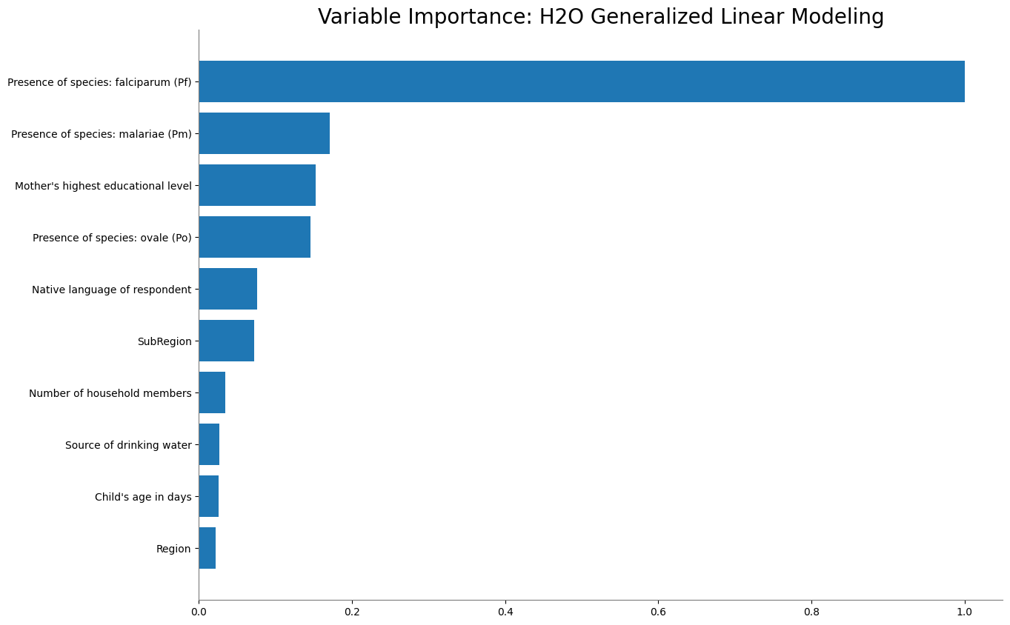

Fig.6.1 Features Importance Graph based on GLM Model

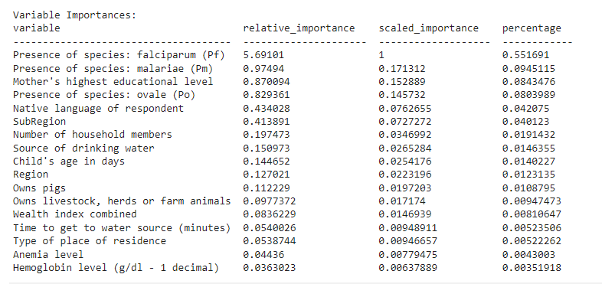

Fig.6.2 Features Importance with value based on GLM Model

from Fig.6.2 we can find that Presence of species: falciparum (Pf), Presence of species: malariae (Pm), Mother's highest educational level and Presence of species: ovale (Po) are the most important features. We also come to know thar three features among top four are clinical factors and one is social factor.

**7. Conclusion**

**7.1 Summary**

Machine Learning (ML) approach in Health Care is booming. In this study an ML approach is taken to predict the Malaria result (positive/negative) based of Demographic Health Surveys 2021 of Nigeria dataset. Here two traditional ML algorithm Logistic Regression & Decision Tree and an AutoML framework H2O are implemented. H2O AutoML algorithms Generalized Linear Model and Stacked Ensemble performed better than other algorithms in all aspect of seven performance measures in DS1 and DS2 respectively. GLM shows top ten important features. Among Presence of species: falciparum (Pf), Presence of species: malariae (Pm), Mother's highest educational level and Presence of species: ovale (Po) are the top four features.

**7.2 Limitations**

During this study some limitations compromised the best result. The computational and time limitation were the main factors of compromised results. Beside these, the data uncertainty and model uncertainty with irreducible error are also the limitations. For the limitation of time and computational cost we restrict (limit) the H2O AutoML training with five model. If there were no limitations, we will be able to try more than 100 models to find the best model in H2O AutoML.

**7.3 Future Research Direction**

This study is limited to a historical dataset of 2021, one linear, one tress based and one AutoML model. Research with updated data, new features and new algorithms and frameworks like Deep Learning, Semi Supervised Learning, Transfer Learning models and AutoKeras, Auto-Sklearn, TPOT etc. AutoML frameworks can be implemented to get more meaningful and important insights from the datasets. Predictive analysis with AutoML frameworks should be done in a wider range as it is a user-friendly predictive tool and don’t need expertise of Machine Learning, Deep learning or Artificial Intelligence.

**Reference**

[1] World Health Organization, “World Health Organization.” https://www.who.int/news-room/fact-sheets/detail/malaria

[2] Centers for Disease Control and Prevention, “Centers for Disease Control and Prevention.” https://www.cdc.gov/malaria/diagnosis_treatment/diagnosis.html

[3] MedlinePlus, “National Library of Medicine - National Institutes of Health”, [Online]. Available: https://medlineplus.gov/lab-tests/malaria-tests/

[4] DHS, “The DHS Program Available Datasets”, [Online]. Available: https://dhsprogram.com/data/available-datasets.cfm

[5] AutoML.org, “AutoML.org”, [Online]. Available: https://www.automl.org/automl/

[6] G. Kalipe, V. Gautham, and R. K. Behera, “Predicting Malarial Outbreak using Machine Learning and Deep Learning Approach: A Review and Analysis,” in *Proceedings - 2018 International Conference on Information Technology, ICIT 2018*, Dec. 2018, pp. 33–38. doi: 10.1109/ICIT.2018.00019.

[7] Y. W. Lee, J. W. Choi, and E.-H. Shin, “Machine learning model for predicting malaria using clinical information,” *Comput. Biol. Med.*, vol. 129, p. 104151, Feb. 2021, doi: 10.1016/j.compbiomed.2020.104151.

[8] O. Nkiruka, R. Prasad, and O. Clement, “Prediction of malaria incidence using climate variability and machine learning,” *Informatics Med. Unlocked*, vol. 22, Jan. 2021, doi: 10.1016/j.imu.2020.100508.

[9] S. S. Yadav, V. J. Kadam, S. M. Jadhav, S. Jagtap, and P. R. Pathak, “Machine learning based malaria prediction using clinical findings,” in *2021 International Conference on Emerging Smart Computing and Informatics, ESCI 2021*, Mar. 2021, pp. 216–222. doi: 10.1109/ESCI50559.2021.9396850.

[10] M. O. Arowolo, “ICA LEARNING APPROACH FOR PREDICTING OF RNA-SEQ MALARIA VECTOR DATA CLASSIFICATION USING SVM KERNEL ALGORITHMS,” 2022.

[11] G. Shekar, S. Revathy, and E. K. Goud, “Malaria Detection using Deep Learning,” in *Proceedings of the 4th International Conference on Trends in Electronics and Informatics, ICOEI 2020*, Jun. 2020, pp. 746–750. doi: 10.1109/ICOEI48184.2020.9143023.

[12] M. Masud *et al.*, “Leveraging Deep Learning Techniques for Malaria Parasite Detection Using Mobile Application,” *Wirel. Commun. Mob. Comput.*, vol. 2020, 2020, doi: 10.1155/2020/8895429.

[13] D. Harvey, W. Valkenburg, and A. Amara, “Predicting malaria epidemics in Burkina Faso with machine learning,” *PLoS One*, vol. 16, no. 6 June, Jun. 2021, doi: 10.1371/journal.pone.0253302.

[14] M. K. Gourisaria, S. Das, R. Sharma, S. S. Rautaray, and M. Pandey, “A deep learning model for malaria disease detection and analysis using deep convolutional neural networks,” *Int. J. Emerg. Technol.*, vol. 11, no. 2, pp. 699–704, 2020, [Online]. Available: www.researchtrend.net

[15] P. Mohapatra, N. K. Tripathi, I. Pal, and S. Shrestha, “Determining suitable machine learning classifier technique for prediction of malaria incidents attributed to climate of Odisha,” *Int. J. Environ. Health Res.*, vol. 32, no. 8, pp. 1716–1732, 2022, doi: 10.1080/09603123.2021.1905782.

[16] B. Muhammad and A. Varol, “A Symptom-Based Machine Learning Model for Malaria Diagnosis in Nigeria,” in *2021 9th International Symposium on Digital Forensics and Security (ISDFS)*, Jun. 2021, pp. 1–6. doi: 10.1109/ISDFS52919.2021.9486315.

[17] H. I. Okagbue, P. E. Oguntunde, E. C. M. Obasi, P. I. Adamu, and A. A. Opanuga, “Diagnosing malaria from some symptoms: a machine learning approach and public health implications,” *Health Technol. (Berl).*, vol. 11, no. 1, pp. 23–37, Jan. 2021, doi: 10.1007/s12553-020-00488-5.

[18] N. O. Adeboye, O. V. Abimbola, and S. O. Folorunso, “Malaria patients in Nigeria: Data exploration approach,” *Data Br.*, vol. 28, Feb. 2020, doi: 10.1016/j.dib.2019.104997.

[19] M. O. Arowolo, M. O. Adebiyi, A. A. Adebiyi, and C. Aremu, “An ICA-ensemble learning approaches for prediction of RNAseq malaria vector gene expression data classification,” *Int. J. Electr. Comput. Eng.*, vol. 11, no. 2, pp. 1561–1569, Apr. 2021, doi: 10.11591/ijece.v11i2.pp1561-1569.

[20] O. A. Abisoye and R. G. Jimoh, “Comparative Study on the Prediction of Symptomatic and Climatic based Malaria Parasite Counts Using Machine Learning Models,” *Int. J. Mod. Educ. Comput. Sci.*, vol. 10, no. 4, pp. 18–25, Apr. 2018, doi: 10.5815/ijmecs.2018.04.03.

[21] N. Maurice *et al.*, “Malaria Epidemic Prediction Model by Using Twitter Data and Precipitation Volume in Nigeria,” *Multimed. Soc.*, vol. 22, no. 5, pp. 588–600, 2019, doi: https://doi.org/10.9717/kmms.2019.22.5.588.

[22] M. Masinde, “Africa’s Malaria Epidemic Predictor: Application of Machine Learning on Malaria Incidence and Climate Data,” in *ACM International Conference Proceeding Series*, Mar. 2020, pp. 29–37. doi: 10.1145/3388142.3388158.

[23] B. J. Brown *et al.*, “Data-driven malaria prevalence prediction in large densely populated urban holoendemic sub-Saharan West Africa,” *Sci. Rep.*, vol. 10, no. 1, Dec. 2020, doi: 10.1038/s41598-020-72575-6.

[24] O. N. Bridget, “Machine Learning Techniques for Malaria Incidence and Tuberculosis Prediction,” African University of Science and Technology (AUST), 2021. Accessed: Jan. 26, 2023. [Online]. Available: http://repository.aust.edu.ng/xmlui/handle/123456789/5096

[25] A. P. Idowu, N. Okoronkwo, and R. E. Adagunodo, “Spatial Predictive Model for Malaria in Nigeria,” 2009. [Online]. Available: www.jhidc.org

[26] DHS, “The DHS Program Survey Methodology - Malaria Indicators Survey (MIS)”, [Online]. Available: https://www.dhsprogram.com/Methodology/Survey-Types/MIS.cfm

[27] DHS, “Demographic and Health Surveys Methodology (Variable Descriptions),” 2013, [Online]. Available: https://dhsprogram.com/publications/publication-dhsg4-dhs-questionnaires-and-manuals.cfm

[28] S. Sawangarreerak and P. Thanathamathee, “Random Forest with Sampling Techniques for Handling Imbalanced Prediction of University Student Depression,” *Information*, vol. 11, no. 11, p. 519, Nov. 2020, doi: 10.3390/info11110519.